Columba Cantata Script

A Cantata for Schools by Gerry Fitzpatrick and Noel Colford

- 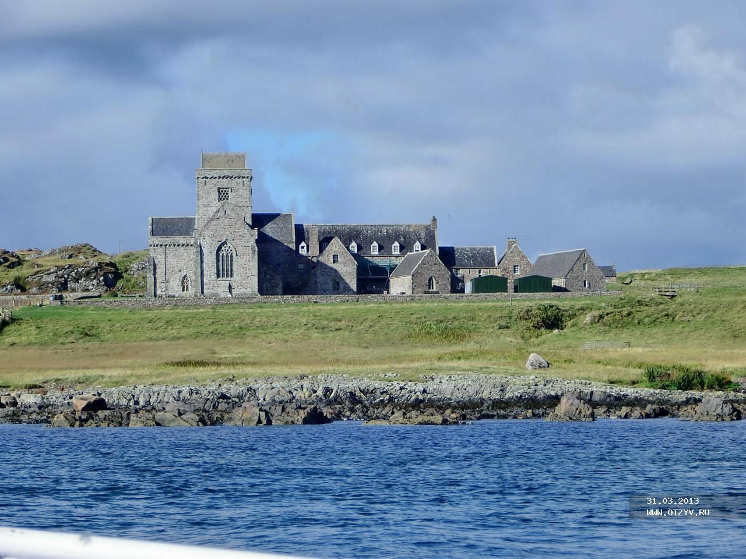

Iona

- The story begins

chorus
Columba! Columba, so many hopes were pinned on you!
Columba! Columba, so many hopes were pinned on you!

Verse 1: Columba as a little boy, went to the Abbey school,
Was taught by abbot and by bard and then became a monk.
He preached the word of God to every mother, child and dad,
And so throughout the country people learned about the Lord.

Columba! Columba, so many hopes were pinned on you!
Columba! Columba, so many hopes were pinned on you!
Verse 2 A holy man, Columba spent some time in prayer each day;
He listened to the Gospel and he sang King David’s psalms.
He borrowed Finian’s psalmbook and he copied it at night,
Though others thought he’d need permission since he had no right.

Columba! Columba, so many hopes were pinned on you!
Columba! Columba, so many hopes were pinned on you!
Verse 3 ‘I don’t know why there’s so much fuss about a pen and ink!
I only want to spread the holy Word of God, I think!
It surely can’t be wrong to share the psalms that we’ve received,
But there were many others who did not agree with him.

Columba! Columba, so many hopes were pinned on you!
Columba! Columba, so many hopes were pinned on you!

Verse 4 All those who did not think like him began to get upset,
The King was forced to intervene, but this had no effect!
‘To every cow its calf’ he said, but fighting soon began,
And sword and spear and armour once again were in demand.

Columba! Columba, so many hopes were pinned on you!
Columba! Columba, so many hopes were pinned on you!

No 2 The battle and exile

The battle raged and reeled and roared on ev’ry side,
People beaten, battered and bemused.
‘To ev’ry cow its calf,’ they’d cried but still the peace was never tried,
And families divided met in war.

O Columba, what will you do? O Columba, what’s ahead of you?

Columba fled the country shunned by everyone,
Exiled with a dozen close companions,
Pilgrims of the Lord they found an island in the Western Sea,
Iona, where they built their monast’ry.

O Columba, what will you do? O Columba, what’s ahead of you?

No 3: The mission

Columba set out for Inverness
To talk to the Picts without much success
Since they locked the doors and wouldn’t speak to him.
It’s so good to praise the Lord,
It’s so good to thank the Lord,
To bless him and to glorify his name.

Columba said: ‘Friends, let’s praise the Lord.”
They shouted out with one accord!
The gates opened wide so they could walk right in!
It’s so good to praise the Lord,
It’s so good to thank the Lord,
To bless him and to glorify his name.

They said “We’re afraid of an ugly big monster,
She lives in the loch, though nobody wants her;
When she’s around then people disappear.
It’s so good to praise the Lord,
It’s so good to thank the Lord,
To bless him and to glorify his name.

Columba went out to find this beast,
Called Nessie by name; when it did appear he showed it the cross;
It disappeared from sight!
It’s so good to praise the Lord,
It’s so good to thank the Lord,
To bless him and to glorify his name.

- Finale

Columba taught the clansmen how to live in peace;
Brude the king was overcome by goodness.
He had learnt that love of God
could make the Pictish people happy;
Fighting only made the matter worse.
Great Columba! Prophet of Peace!
St Columba, pilgrim for the Lord.

Iona freed Columba from the troubled past.
Here he understood what God was saying.
Through prayer and love he softened hearts
and opened minds to look for goodness;
Love of God became a love for all.
Great Columba! Prophet of Peace!
St Columba, pilgrim for the Lord.

Words and music © Gerry Fitzpatrick except for words and music of No 3 © Noel Colford. Thanks to David Morris for his helpful suggestions.

COLUMBA & THE LAW OF THE INNOCENTS – CHILDREN’S CANTATA 2013

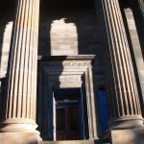
Wellington Church

Each year we tell ourselves this was the best one yet – the best children’s Cantata, that is – but each year the primary schools and everyone else involved in the ecumenical event (sponsored by Glasgow Churches Together) excel themselves. This year’s Cantata was held in a new venue, the beautiful Wellington Church of Scotland in University Avenue, hosted by the minister Dr. David Sinclair and his congregation.
Twenty primary schools took part:- Bankhead Primary; St Bartholomew’s; St Clare’s; St Conval’s; Dalmarnock Primary; Garscadden Primary; Golfhill Primary; John Paul II Primary; St Martha’s; St Mary’s; St Monica’s; Motherwell Cathedral Primary; St Ninian’s; Our Lady of the Missions; Our Lady of the Rosary; St Paul’s; St Philomena’s; St Roch’s; St Timothy’s and St Saviour’s, and they filled the church.
It was a cold day but the children filled the church pews with warmth and enthusiasm. They were joined by singers and musicians from the Education Department of the University of Glasgow under B.Ed. Music Programme Leader, Miss Moira Summers, and, since they had well rehearsed the music from a CD recorded by Carissa Bovil, they soon filled the church with music and colour as well. Adding to the colour was great bunting with the flags of the Commonwealth nations (kindly donated by David Buchan of the Flag Company).
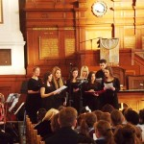
The students singing “Iona”

After a brief rehearsal, under the guidance of conductor Maria Shields, the event began with the B.Ed. students presenting the beautiful song “Iona” . Then, as children from St. Monica’s, dressed as monks and clansmen, processed in with the Bible to the front of the church, the musicians led the combined schools in singing “God our Creator”, celebrating the gifts of God to them and their families and friends. The Bible was then reverently placed on the lectern as a prayer was read.
Pupils from Golfhill Primary School welcomed everyone in English and Gaelic to the celebration before a pupil from Our Lady of the Missions School read an extract from Adamnan’s Life of St. Columba. This was followed by the singing of Psalm 18 (setting by Mary Dickie and beautifully sung by Our Lady of the Rosary Primary pupils) and a reading from St. Paul’s Letter to the Romans.
Then the Cantata proper started with a pupil from John Paul II primary outlining the story. Each section of the Cantata was led very effectively by different school. The sound was wonderful and it was difficult to believe that these twenty schools had all practised separately and only come together on the day. They sang as one with real enthusiasm.
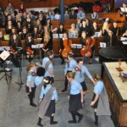
Our young dancers
At the end of the Cantata, pupils from St. Ninian’s Primary rounded it off fittingly with a lively performance of Scottish country dancing. Then there was a brilliant presentation of a “Newflash” about the proclamation of Adamnan’s Law of the Innocents, courtesy of Ken Mallard of Glasgow University, Hugh Kelly (who was responsible for the amplification of the event) and Wellington Church’s great technical equipment.
Ken had recorded children from St. Paul’s Whiteinch, presenting “the news from 697 AD” introduced by the well-known music from a certain TV news programme! The “newsreaders” explained what the Law of the Innocents was about and how it had been achieved by St. Adamnan (or Eunan). The children clearly were fascinated by this presentation and there wasn’t a sound in the church as they watched it. Then the B.Ed. students sang “Adamnan’s Song”.
Intercessions were then read and signed by children from St. Roch’s Primary for the people of Scotland and Glasgow, with particular mention of the forthcoming Commonwealth Games

1. Columba loved the island of Iona. He worked and prayed there, and his message of love and peace spread throughout the land of Scotland. May we bring that message of love and peace to all the people that we know, and make our world a better place.
Lord hear us.

2. Bless all people of goodwill and of different faiths who pray and work together for the good of those around them. May their efforts bring about a more peaceful and just society where the rights of all people are respected . Lord hear us

3. Bless all the people of Scotland. May we follow the example of Columba and Adamnan and make Scotland a land where everyone can feel welcomed and all can find a home . May we remember to help all those in need , and be a friend to the stranger. Lord hear us

4. Bless this city of Glasgow as we prepare for the Commonwealth Games next year. May all the citizens of Glasgow give a kindly welcome to visitors from other lands and offer them generous hospitality.
Lord hear us

The prayers began with the singing of the hymn used in connection with the UN Day for World Peace “O Day of Peace”, and ended with the praying of the Lord’s Prayer.
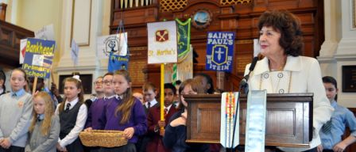
Baillie Clark with some of the schools

As is traditional at the Cantatas, a collection was taken up for charity. This year it was for the Lord Provost’ Fund to be used for children in need, and Baillie Margo Clark (representing the Lord Provost) accepted the donations brought down in procession by the children to the front of the church. Baillie Clark took the opportunity not only to thank the children for their generosity to those in need. but for inviting her to a wonderful morning and a wonderful performance, which had taken a great deal of organisation.
She was honoured to represent the Lord Provost at the Cantata and told the children that they had been so professional and accomplished. She now knew a great deal more about St. Columba than she had before as a result. Music-making is a marvellous experience, she said, and can give great pleasure throughout life, and she encouraged them to keep up their skills. She also told the children she kept a “memory box” and asked them to send her things from their experience of the Cantata to put in it – perhaps they should also think of keeping a memory box!
Mr. Jim Whannel of the Education Department expressed his thanks on behalf of the Department to all involved. He joked that he now needed spectacles to read but he had not needed them this morning; he could hear the music and the words the children sang. Referring to the bunting decorating the church and to the words of the Day of Peace hymn, he drew attention to the references to wolves and lambs and the fact that some flags will have wolves behind them and some lambs, and invited the children to think why this should be?
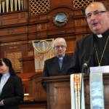
Archbishop Tartaglia with Dr. Sinclair and Rev. Karen Hendry
The children themselves then presented the vote of thanks to all who had made the day possible (including in particular Maria Warrington the Music Development Officer for Primary Schools) and managed to include a subtle hint that they had really liked the venue and wouldn’t mind getting invited back. Archbishop Tartaglia led the final prayer and the blessing, with Dr. Sinclair and Rev. Karen Hendry.
The celebration finished with the rousing Glasgow Song, with its references to the symbols on the city’s coat of arms and, now, to the Commonwealth Games and the city’s welcome to all. As the children headed back to their schools, excitedly chattering, the guests were welcomed into the Crypt Café of Wellington Church to enjoy homemade soup and baking, and reflect on a wonderful experience.

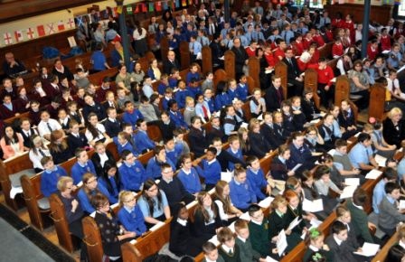
Some of the school children

Morning Prayer
St Columba
2014
Radioalba.org

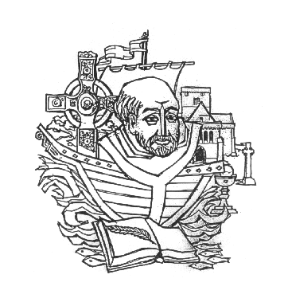

My dearest Lord, be thou a bright flame before me,
be thou a guiding star above me,
be thou a smooth path beneath me,
be thou a kindly shepherd behind me,
today and ever more, today and ever more.

The last words: A Reading from Adamnan’s Life of Columba

These, my children, are my last words to you:
That you have heartfelt love among yourselves.
If you thus follow the example of the holy fathers,
God, the comforter of the good, will be your helper.
And I, abiding with him, will intercede for you,
and he will not only give you sufficient
to supply the needs of this present life,
but will also give you the good and eternal rewards
which are laid up for those who keep his commandments.
O God, come to our aid: O Lord, make haste to help us.
Glory to the Father, glory to the Son,
glory to the Holy Spirit now and for ever. Amen.

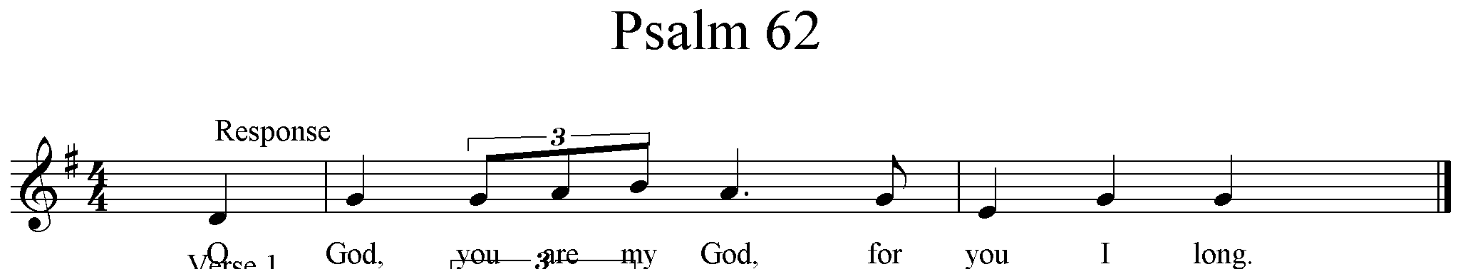

O God, you are my God, for you I long.
O God, you are my God, for you I long, for you my soul is thirsting.
My body pines for you, my God, like a dry weary land without water.
O God, you are my God, for you I long.

I gaze on you in the sanctuary to see your strength and glory,
for your love is better than life itself; my lips will speak your praise.
O God, you are my God, for you I long.

On you I muse throughout the night, on my bed I remember you,
for you have been my refuge and your right hand holds me fast.
O God, you are my God, for you I long.

Short reading Romans 12:1-2
Think of God’s mercy, my brothers, and worship him, I beg you, in a way that is worthy of thinking beings, by offering your living bodies as a holy sacrifice, truly pleasing to God. Do not model yourselves on the behaviour of the world around you, but let your behaviour change, modelled by your new mind. This is the only way to discover the will of God and know what is good, what it is that God wants, what is the perfect thing to do.

Benedictus (verse 1)

Blest be the Lord the God of Israel, who came to us; and brought us back from sin.
God raised for us a Saviour who is mighty; his Saviour-Son from David's house and line.
God promised this through holy men and women
who spoke for him down through the mists of time

The Intercessions (with sung response at the end of each one)

Christ the Lord is the light of the world, the sun which never sets.
Let us praise him, singing:
From the rising of the sun to its setting great is the name of the Lord.
Creator of the stars, we offer you in gratitude the first-fruits of this day,
and we remember your resurrection.
From the rising of the sun to its setting great is the name of the Lord.

May your Spirit guide us today to do what is pleasing to you:
may your Wisdom lead us always.
From the rising of the sun to its setting great is the name of the Lord.

Enable us to look forward to that day
when all your children will be gathered
around the table of your word and the Eucharist.
From the rising of the sun to its setting great is the name of the Lord.

Our souls give you thanks, Lord,
for your immeasurable kindness:
From the rising of the sun to its setting great is the name of the Lord.

Our Father, who art in heaven,
hallowed be thy name.
Thy kingdom come.
Thy will be done on earth, as it is in heaven.
Give us this day our daily bread,
and forgive us our trespasses,
as we forgive those who trespass against us,
and lead us not into temptation,
but deliver us from evil.

Let us pray

Lord, warm our hearts with zeal for your kingdom
and a longing for its fulfilment.
Make our lives rich in good works,
and so bring us to share the glory of Saint Columba,
when we see you face to face and are one with you always.
We make our prayer through our Lord Jesus Christ, your Son,
who lives and reigns with you in the unity of the Holy Spirit,
God for ever and ever.
Amen.

May the Lord bless us and keep us from all harm;
and may he lead us to eternal life.

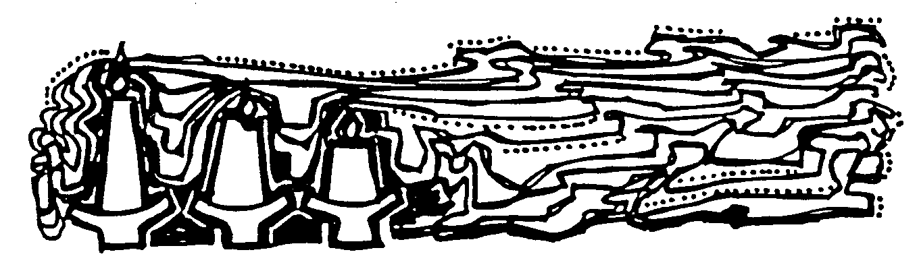

The Altus Prosator of St Columba
Of the Altus Prosator Jane Stevenson writes: 'The poem is outstandingly ambitious in its content: the twenty-three stanzas begin with God and the Creation, and end with the Apocalypse. No other Hiberno-Latin poem has anything like its range and originality. Two long hymns in the seventh-century Antiphonary of Bangor offer a possible point of comparison: `Audite omnes' and `Precamur patrem'. The first is given its shape by recounting the life and work of St Patrick, and the second, more ambitiously, moves from an account of the crossing of the Red Sea to the life of Christ, utilising the natural and metaphorical senses of the word `light' as its central image.
`Altus prosator' describes the relationship of the three persons of the Trinity to each other, the relationship of God to the universe, the place of sin, how the `machina mundi' was set up, how it works, and how it will end, ranging through the Bible from end to end (Genesis to Apocalypse) for its material. It compresses into its twenty-three stanzas all the most essential information about the world, as an early medieval Christian saw it.
In that sense, it may be classed as a didactic hymn of a kind which is characteristic of the Gallican church, as I have argued elsewhere. The attribution of `Altus' to St Columba goes back only to the eleventh-century vernacular prefaces in the two copies of the Irish Liber hymnorum; but it is still widely accepted as `probable', though not, of course, certain.'

