FRIDAY 10th JANUARY 2025 7pm

Vespers of St Mungo
St Andrew’s Metropolitan Cathedral
Clyde St Glasgow

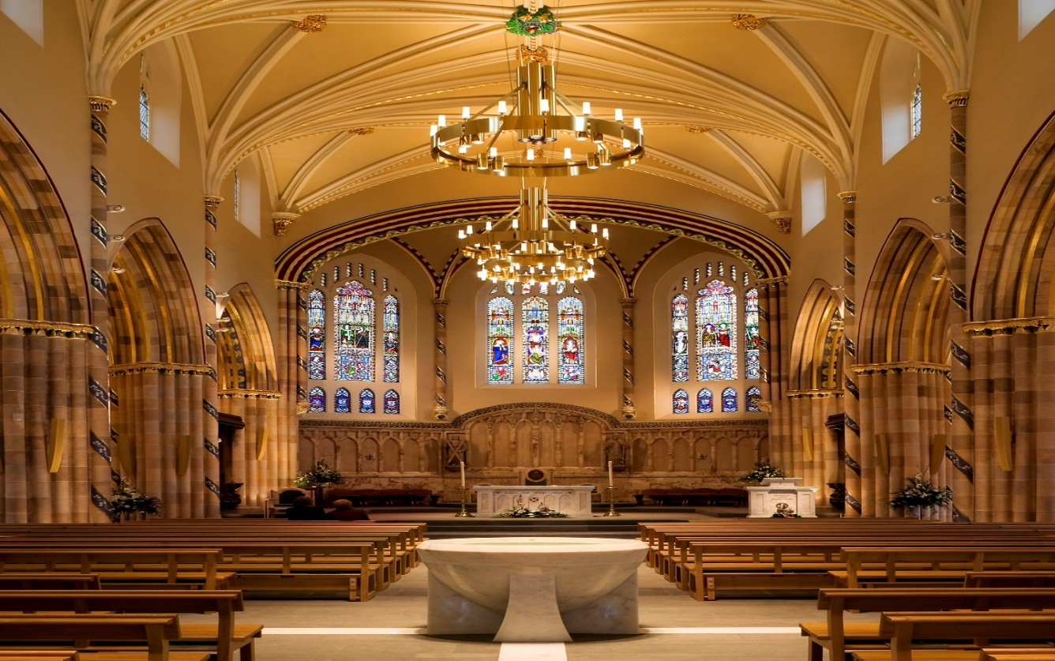

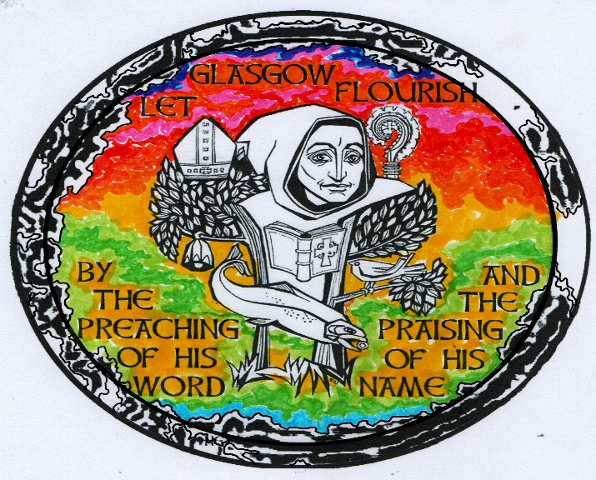

Celebrate the Feast of St Mungo with
The Evening Prayer of the Church
All Welcome

