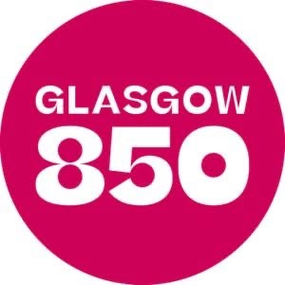
  - Sunday 12th Jan 2024 at 4pm
  - Glasgow Cathedral High St
The Piper will lead a Colourful Procession of
Civic and Church Leaders across the Precinct to the West Doors of the Cathedral to begin the Ecumenical Service,dedicated to the founder of our City,
We will celebrate in word and song the establishment of the city as a Bishop’s Burgh in 1175 in this 850th year of the City of Glasgow

The Music will be led by the St Mungo Singers,

Salvation Army Band,

Andrew Forbes, Musical Director Glasgow Cathedral,

With the Poet Laureate of Glasgow, Jim Carruth

Reflection by Archbishop William Nolan, Archdiocese of Glasgow

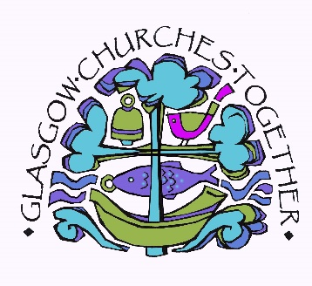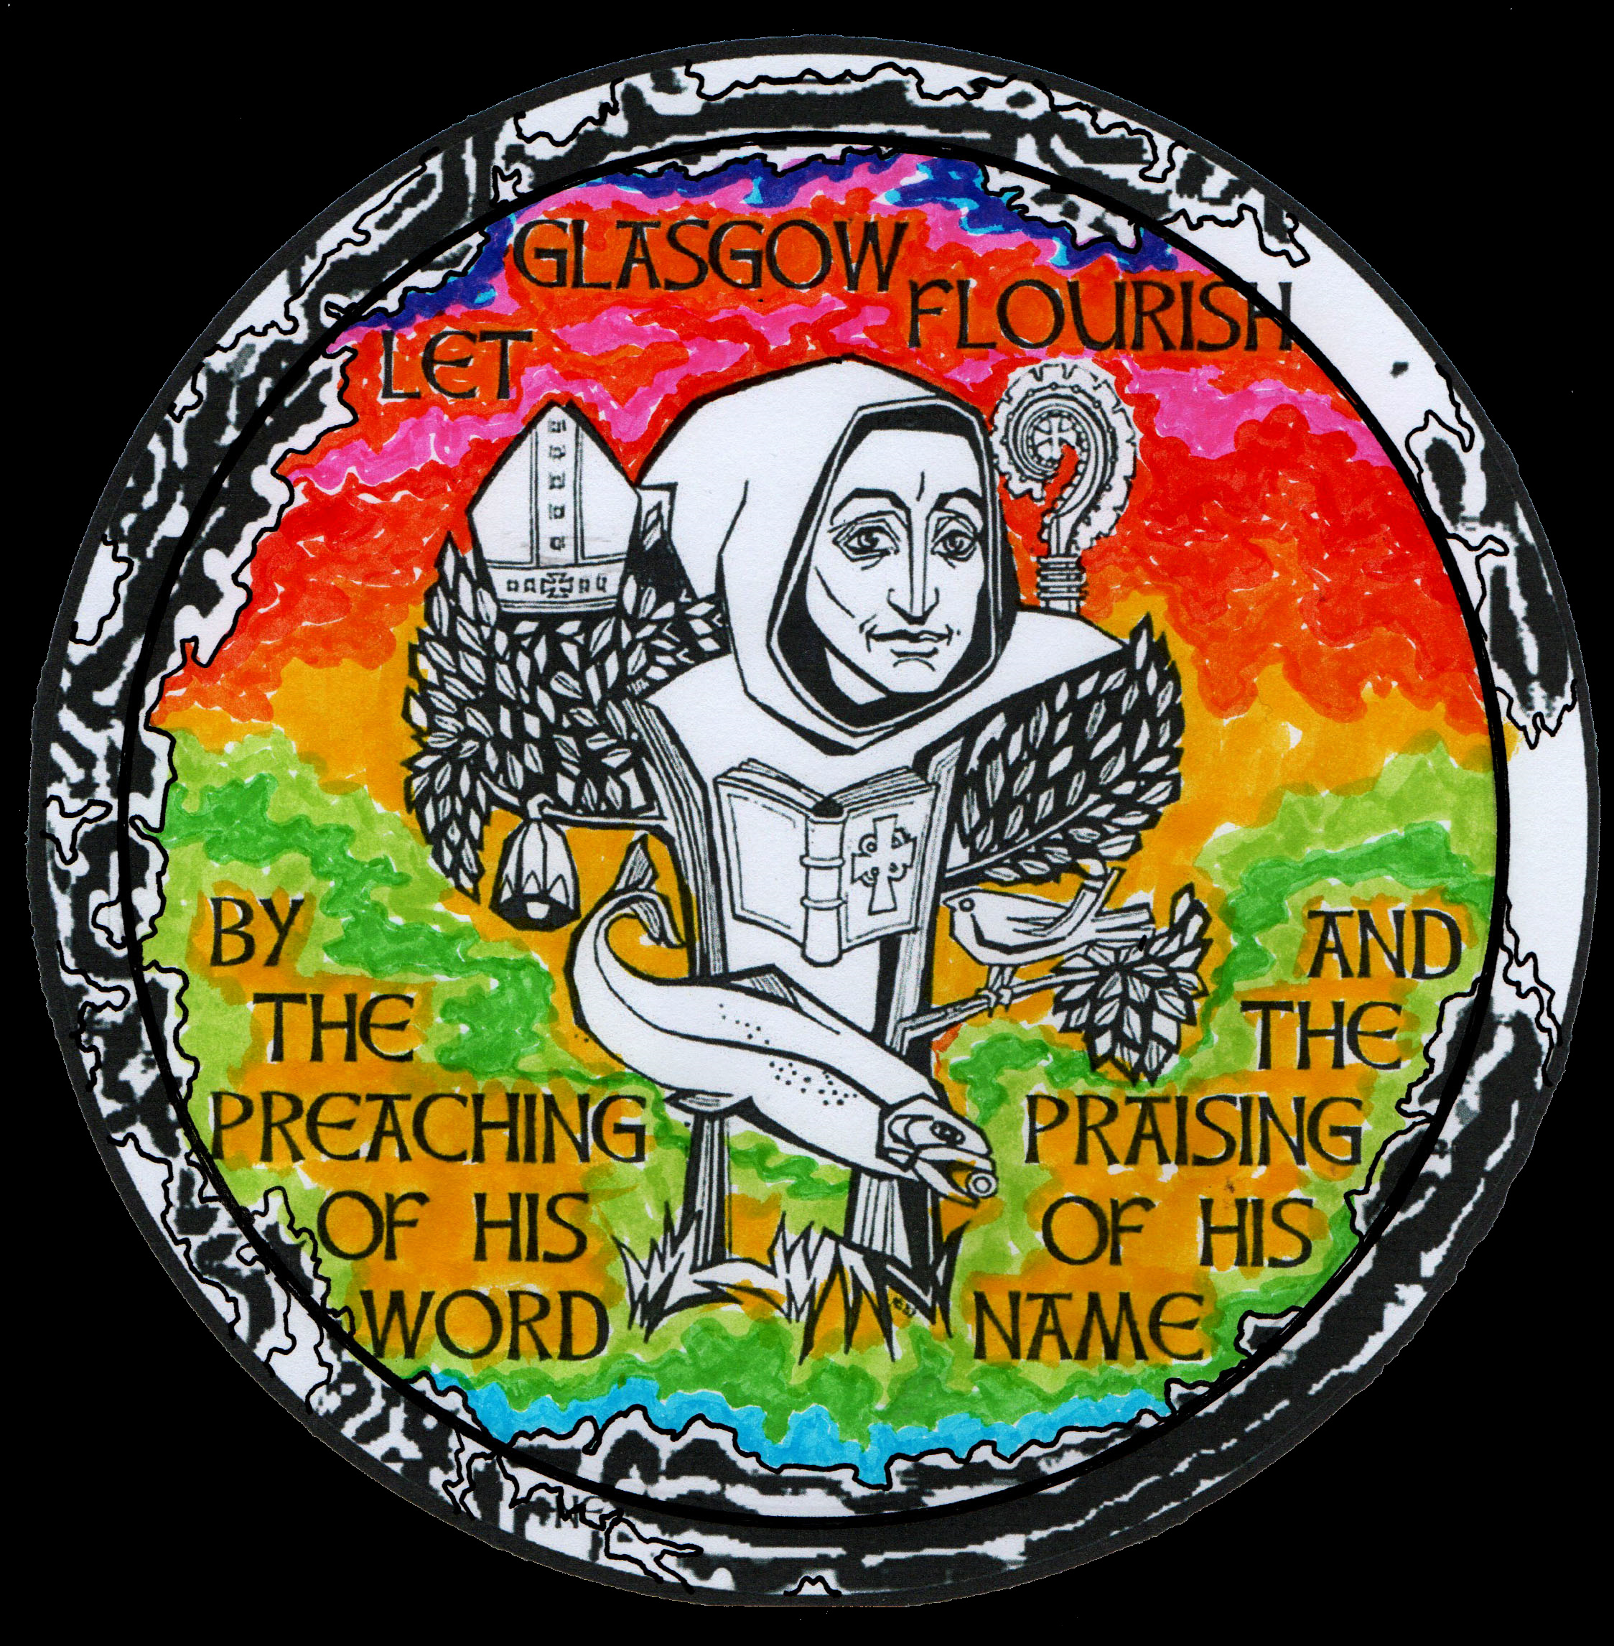
  - All Welcome

