Mass of our celtic roots

4 p.m. Sunday 26th JAN 2025

St. Aloysius, Rose St. Glasgow

Join with clergy of the archdiocese to celebrate our celtic roots,

AS GLASGOW HOSTS the CELTIC CONNECTIONS FESTIVAL
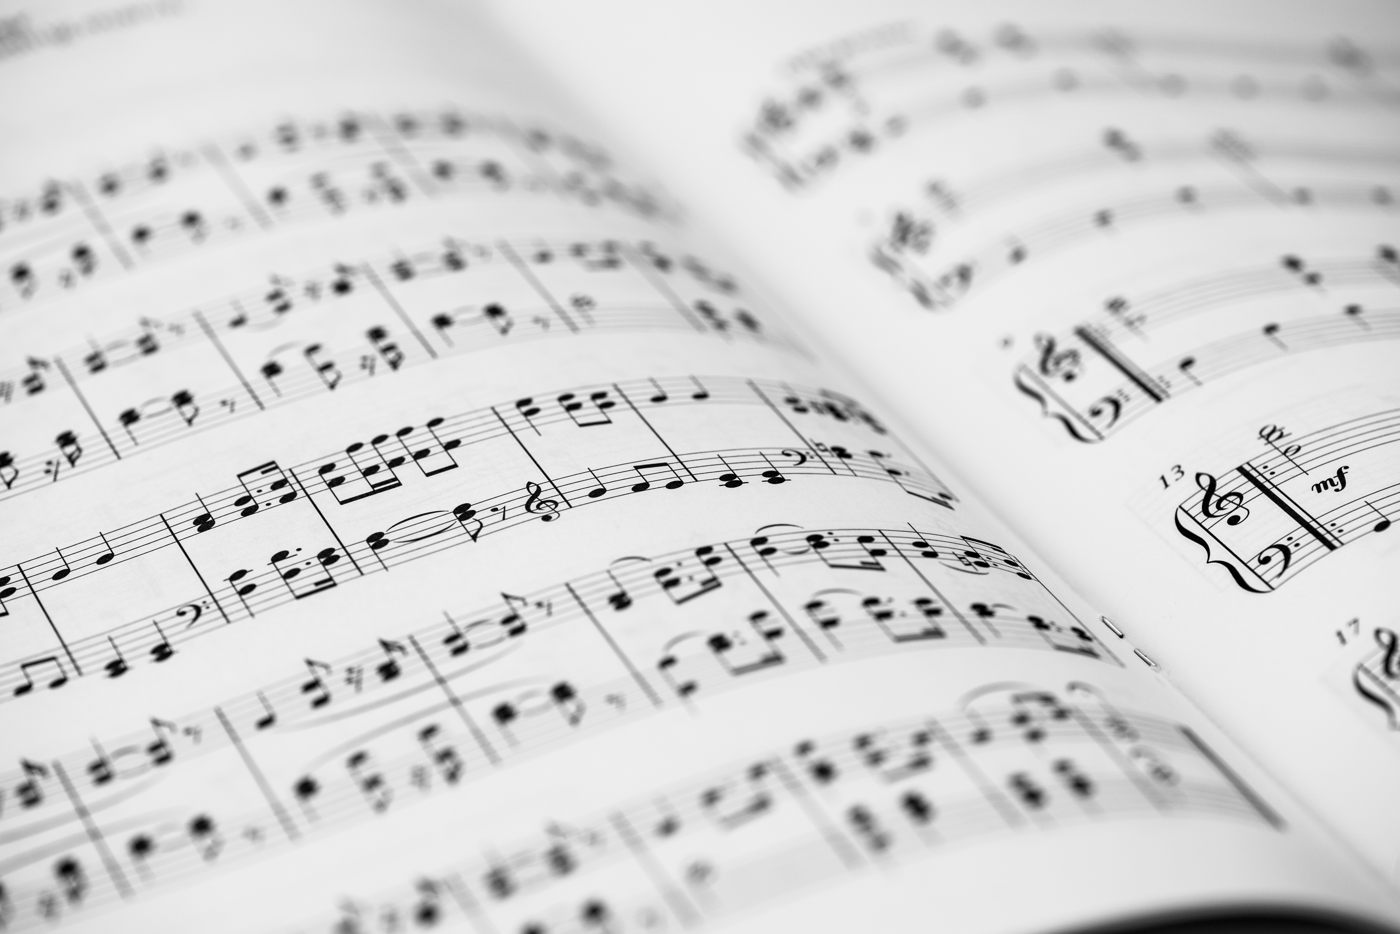

The skirl of CALUM’S pipes will welcome you as you approach Rose St

to Celebrate our Celtic Roots

with Musicians from Glasgow, St Mungo Singers,

St Mungo’s Choir Alloa and the St Mungo Ensemble

The beautiful Celtic Saints Vestments, designed by Netta Ewing and embroidered by the Sacred Threads group will be worn

aLL WELCOME REFRESHMENTS TO FOLLOW

