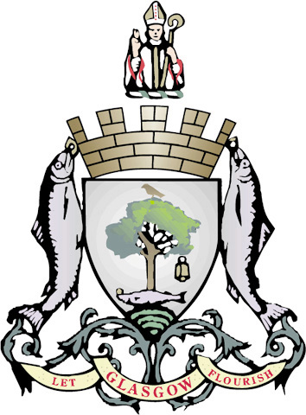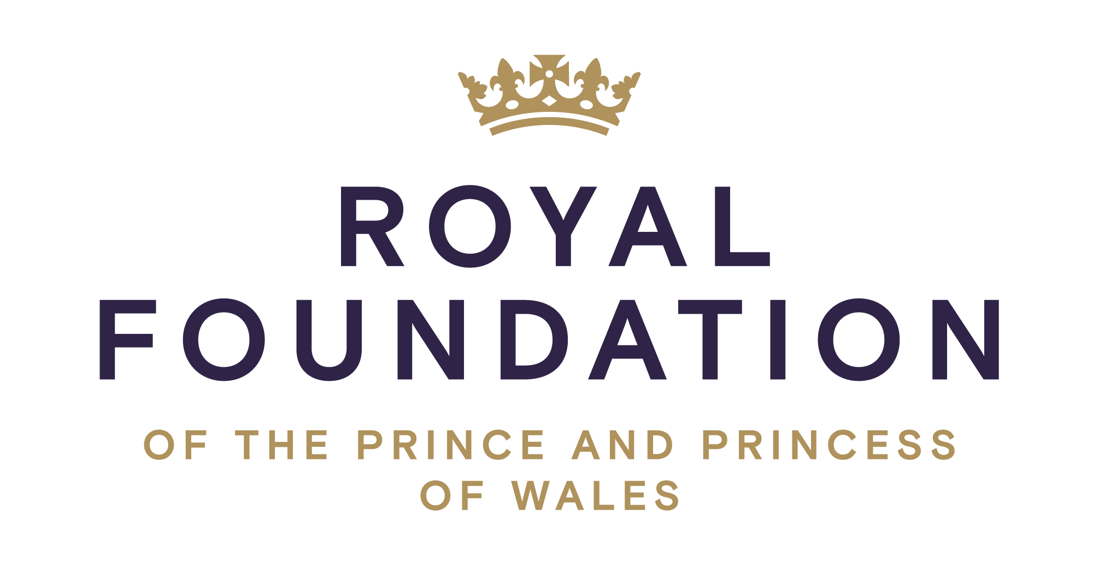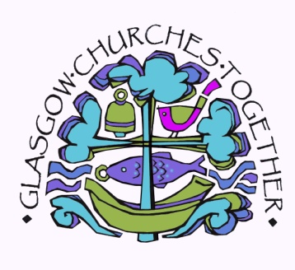
Carols for Peace 2022
Hosted by Glasgow City Council
In partnership with the Royal Foundation of the Prince and Princess of Wales

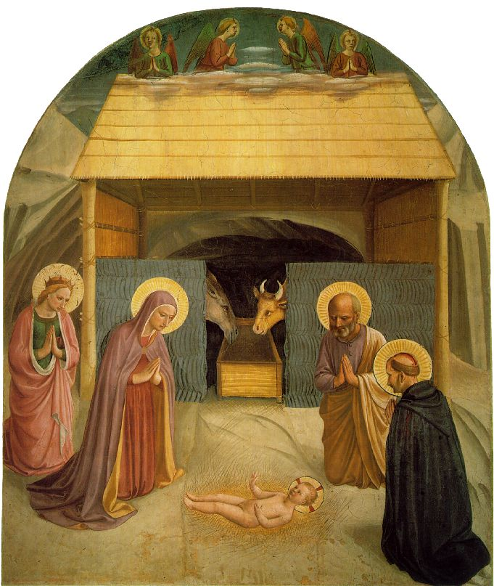

Sunday 11th December 2022 at 3.00pm
Glasgow City Chambers, George Sq

Come and join The Lord Provost, with Glasgow Churches Together
supported by the St Mungo Singers, the Salvation Army Band,
South Side Fiddlers, St Denis’ Primary School,
Piper, Harpist and Music Ensemble
We will pray for peace in our world but particularly Bethlehem, our Twin City

Enjoy refreshments afterwards in the Satinwood Suite overlooking George Square
in all its Christmas Splendour where the Crib still has a place of prominence.

Everyone is welcome to this very important event in the calendar of
Glasgow Churches Together and Glasgow City Council.

A collection will be taken up for the Lord Provost’s Fund for Children

