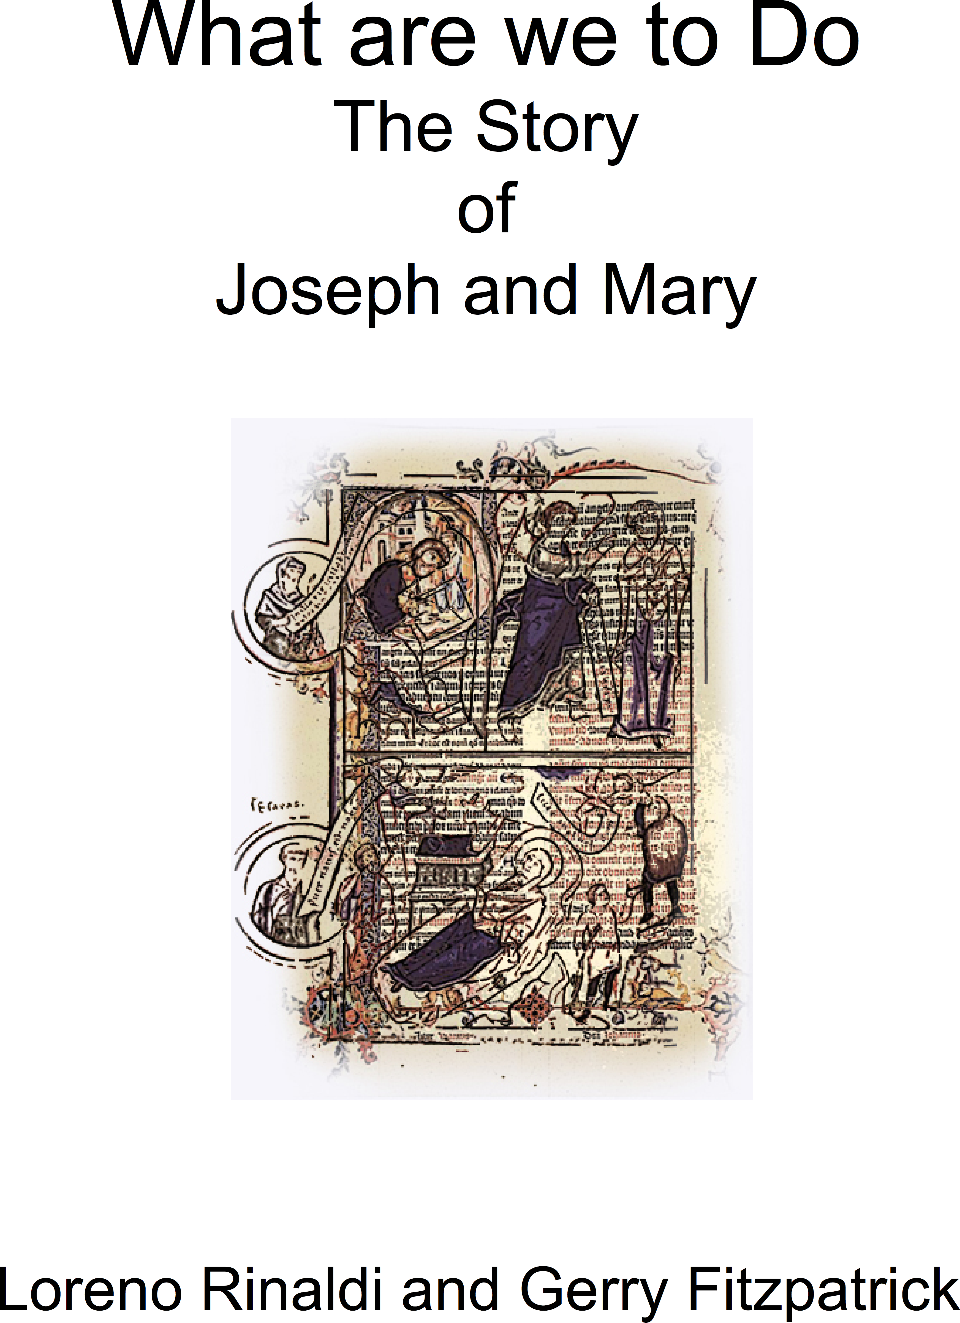
Cover graphic provided by Netta Ewing

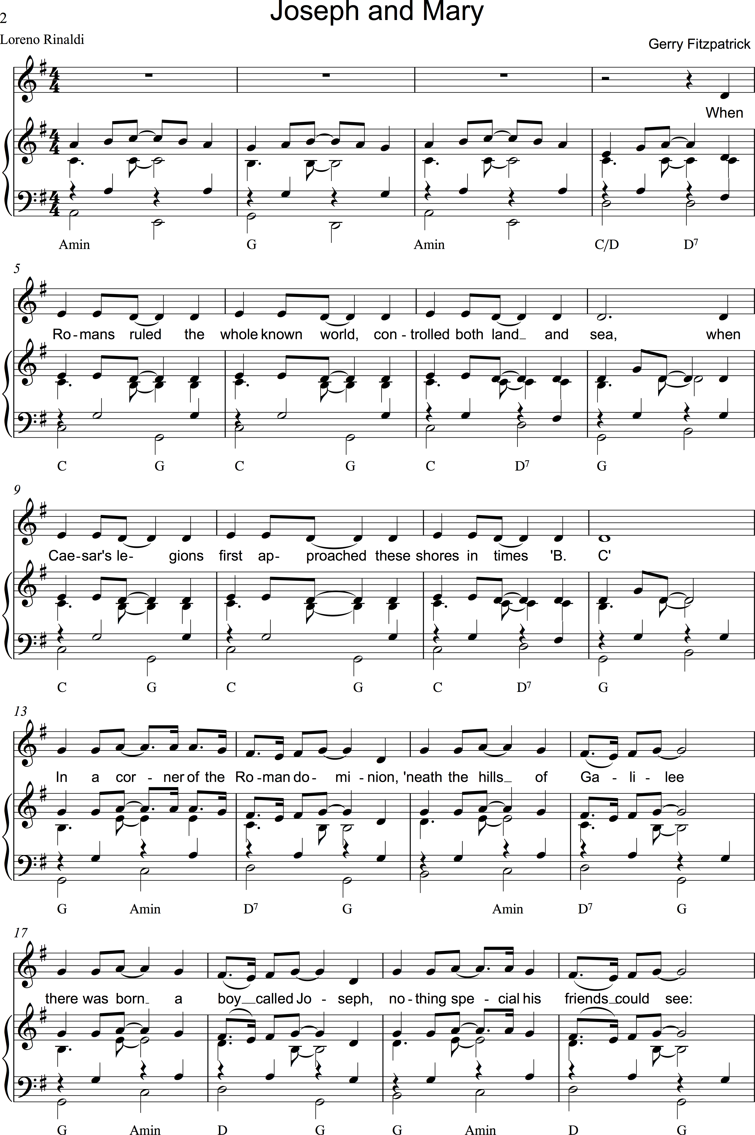
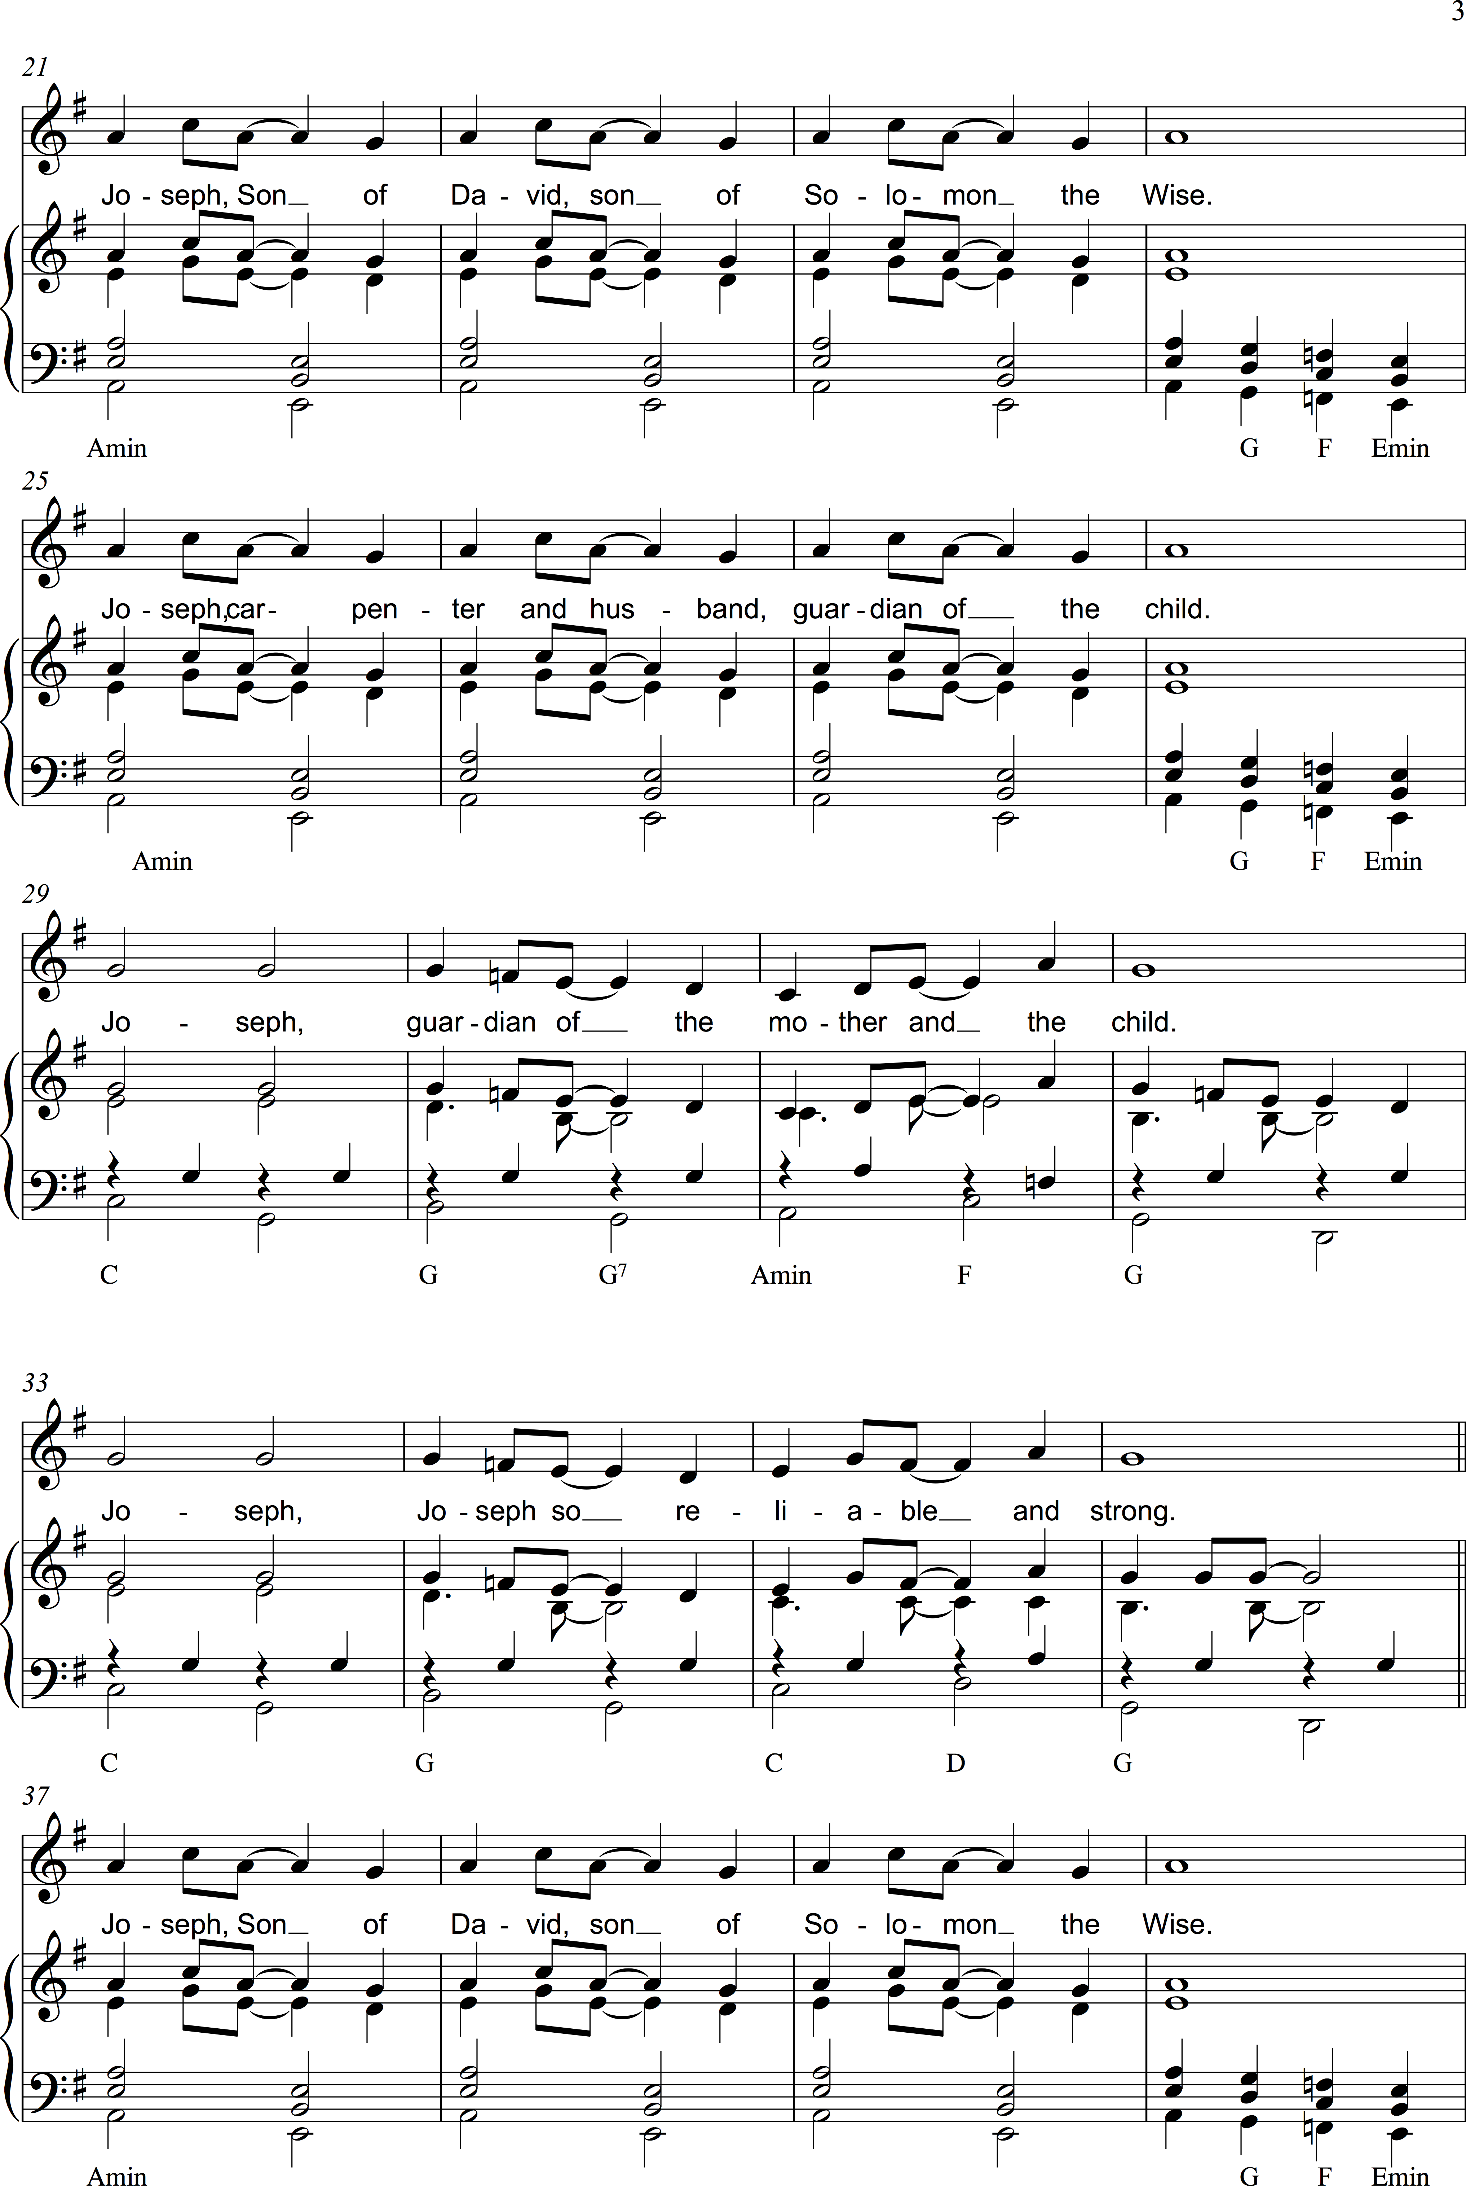

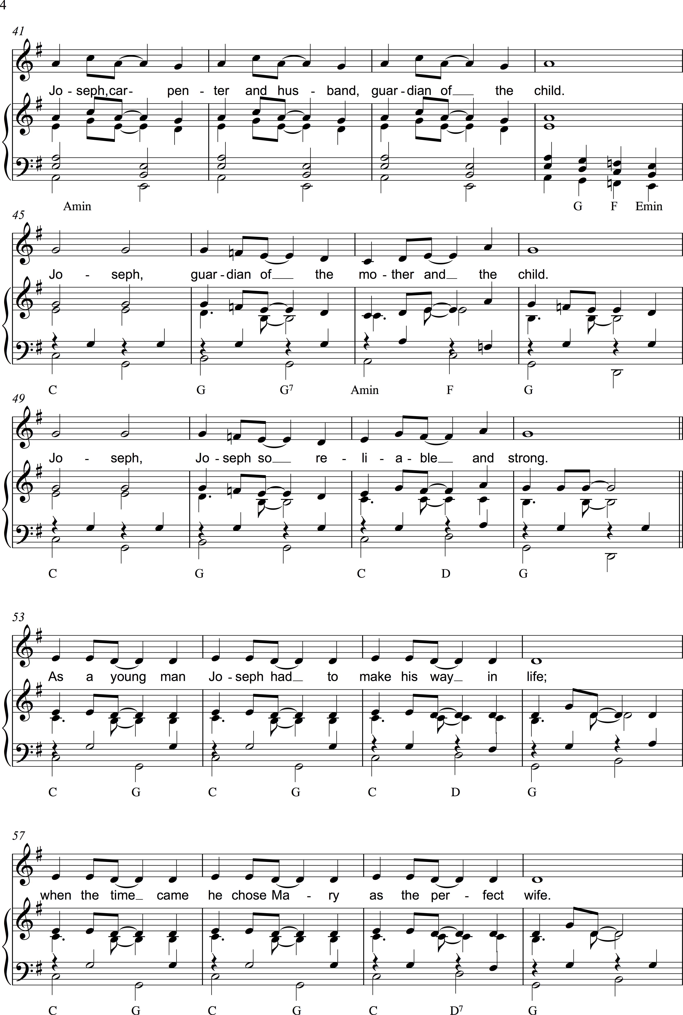

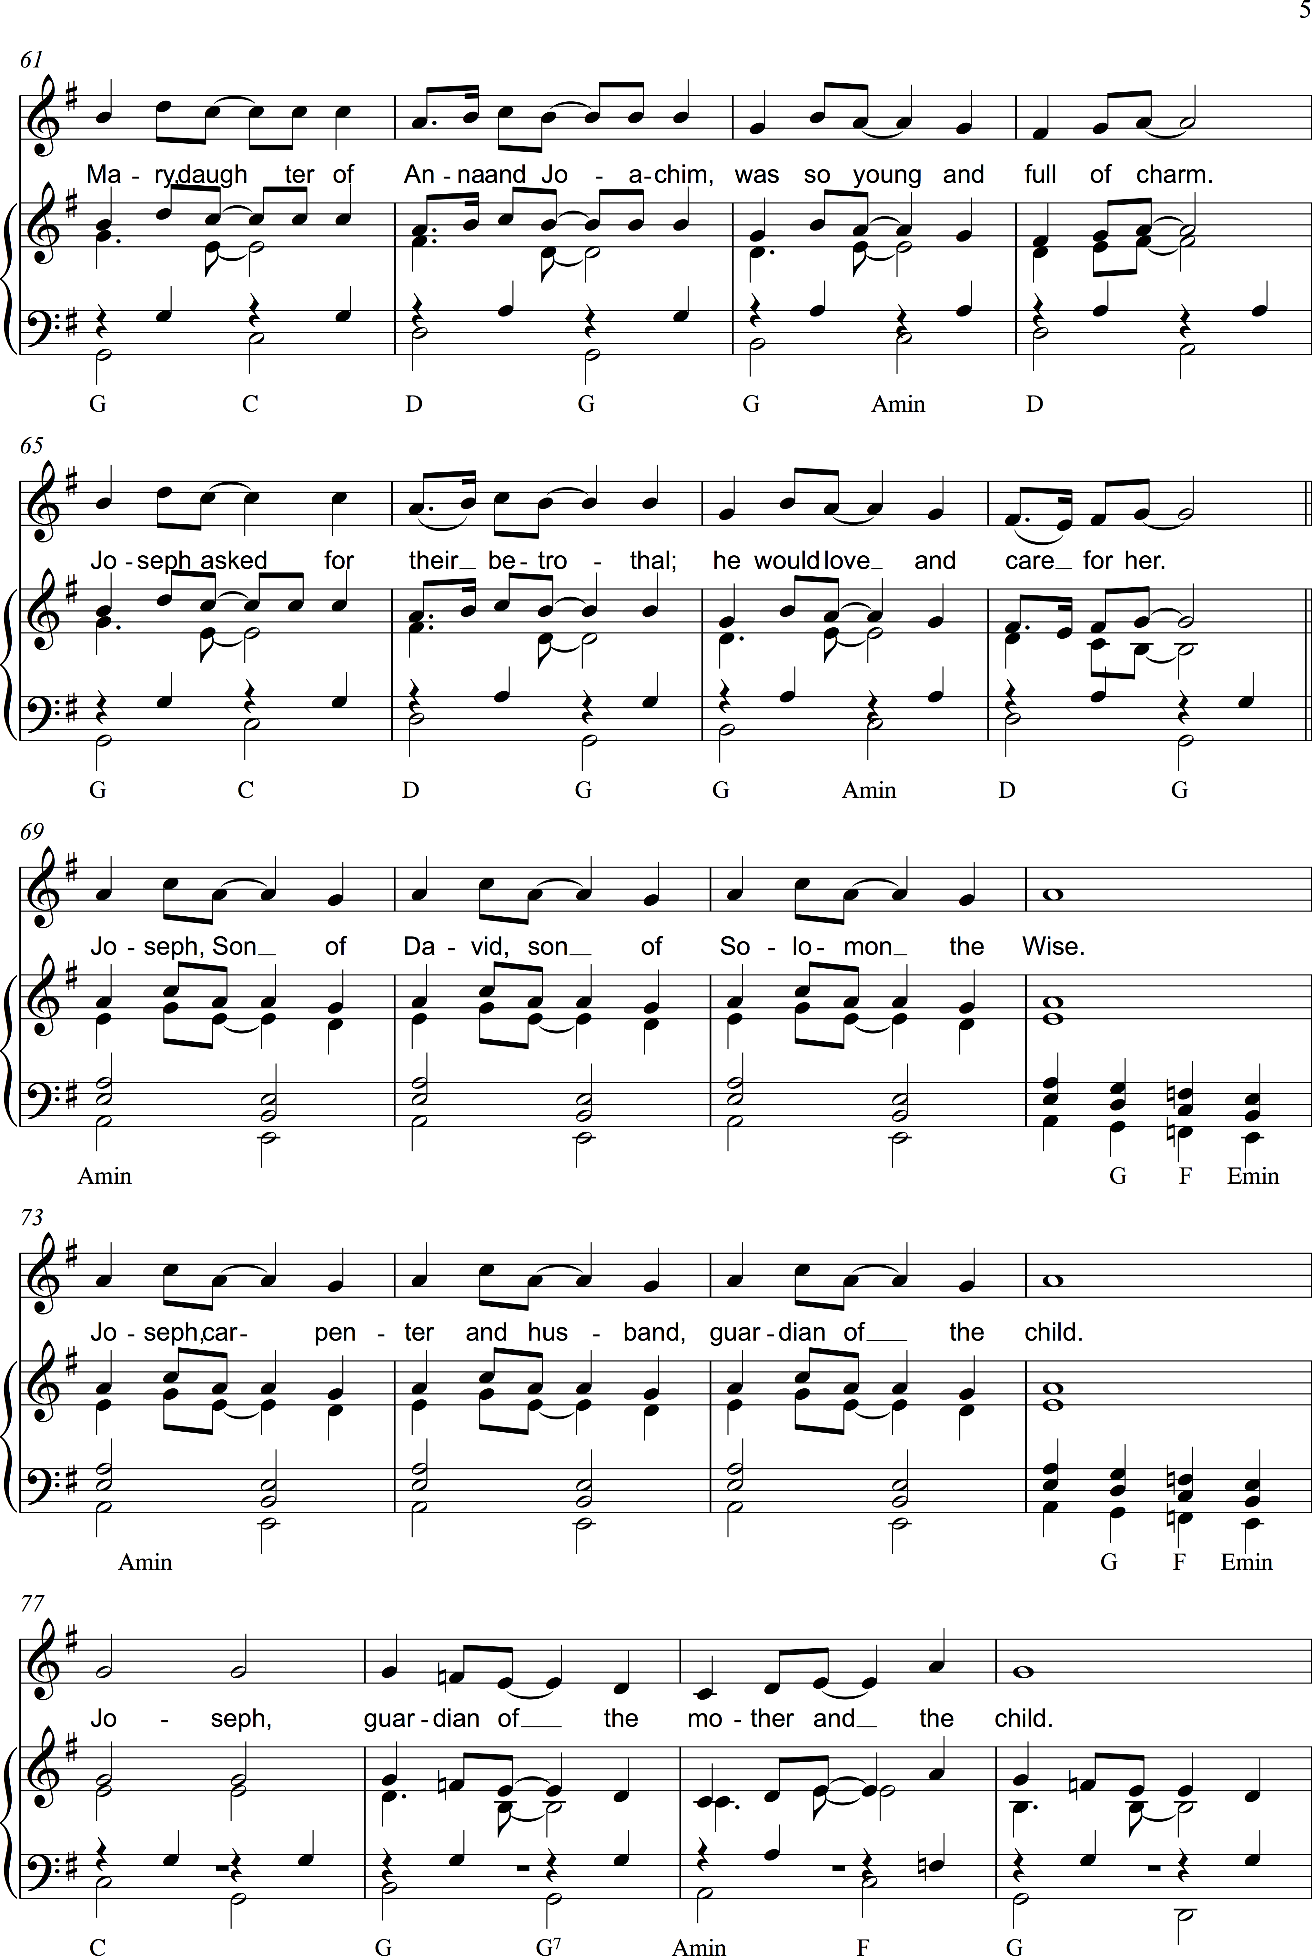

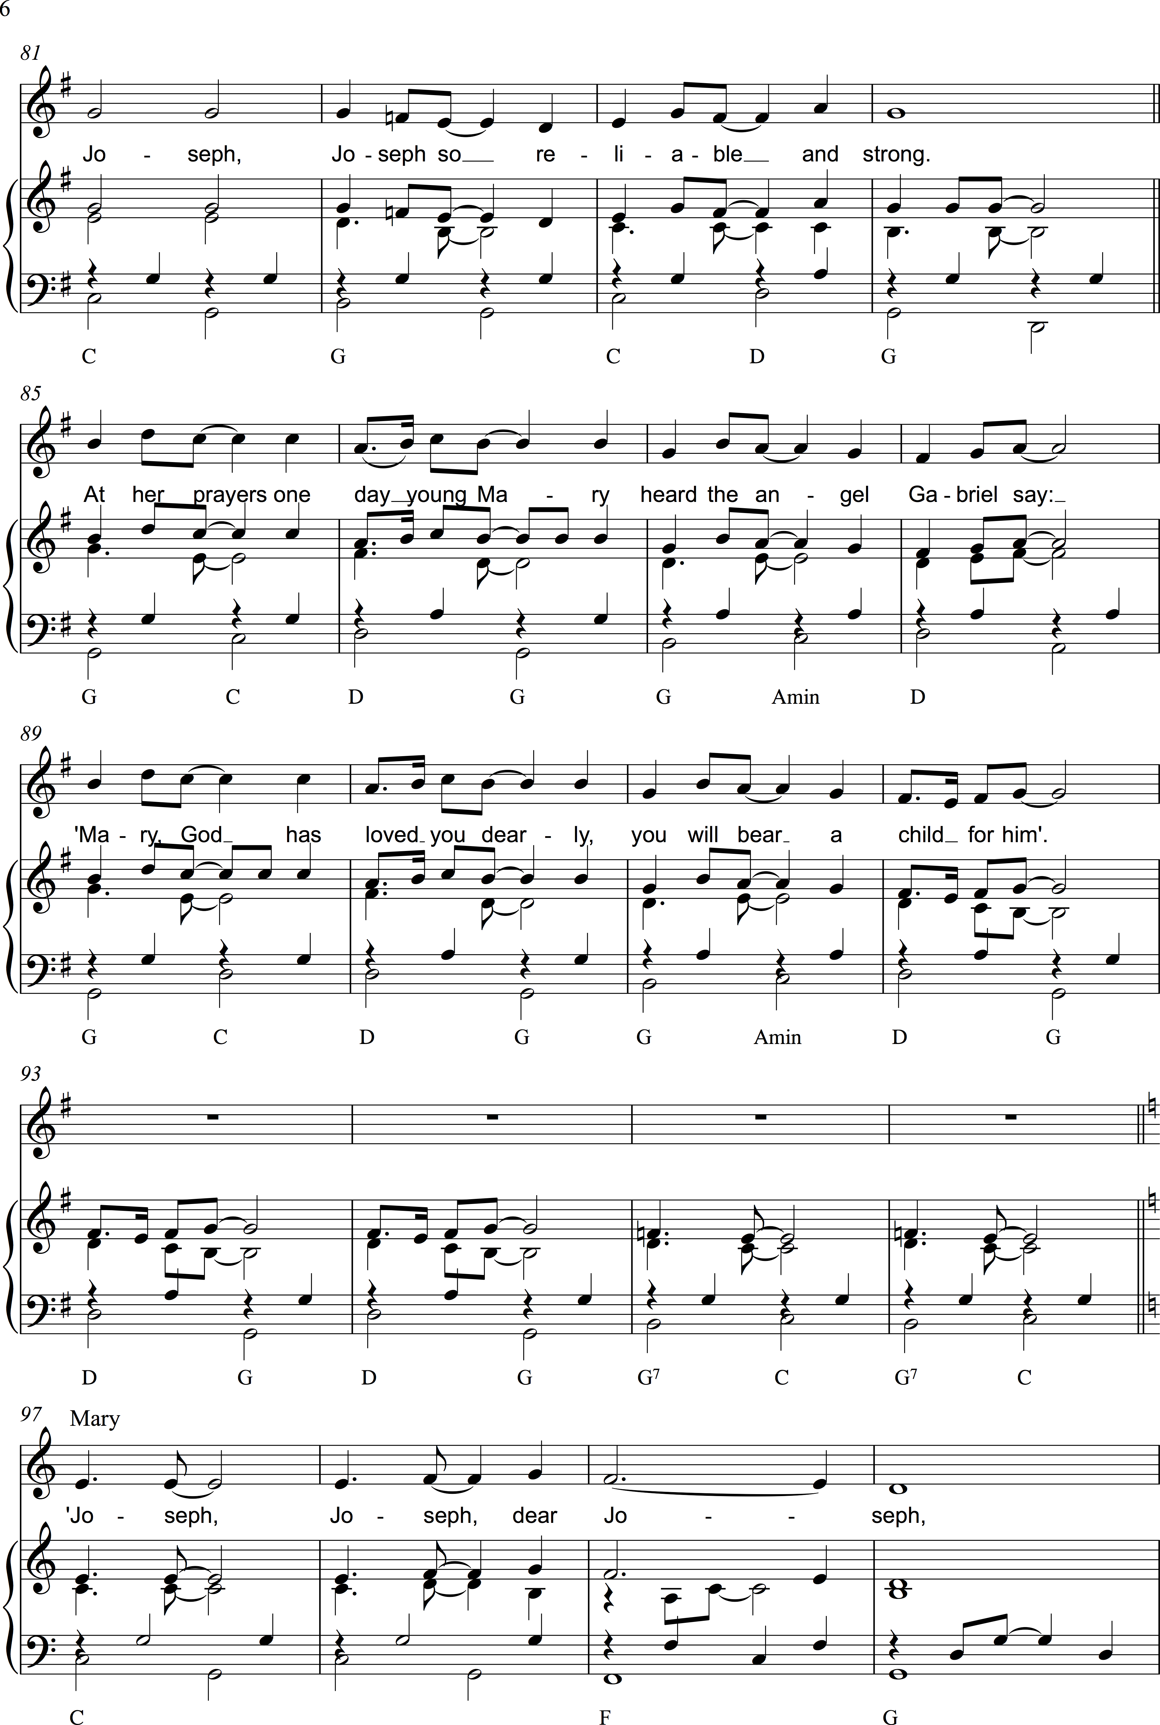

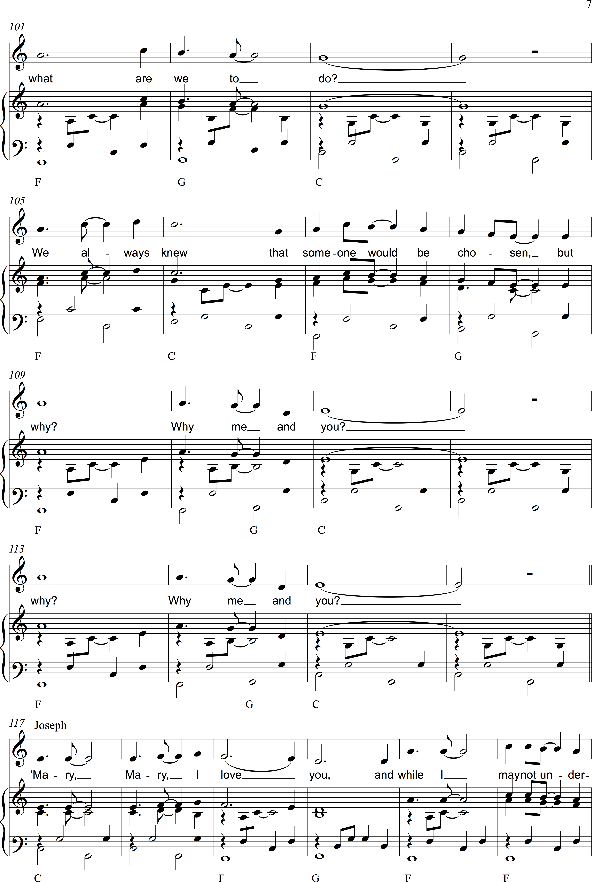

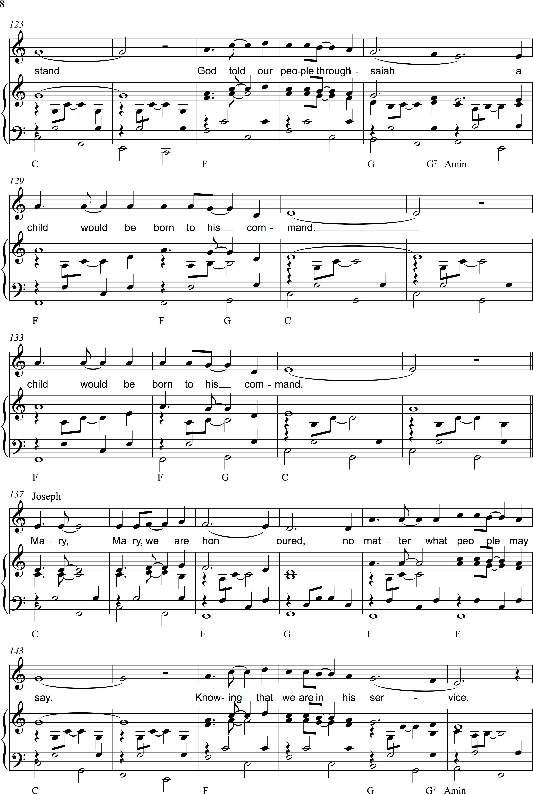

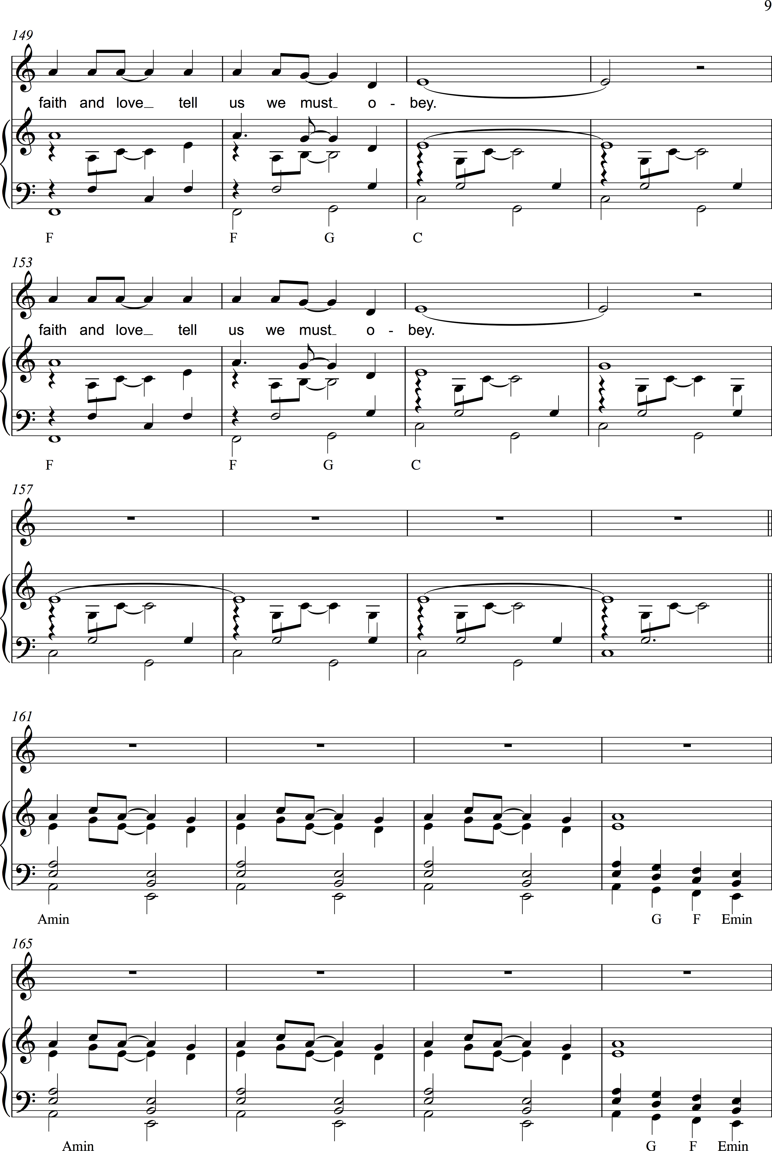

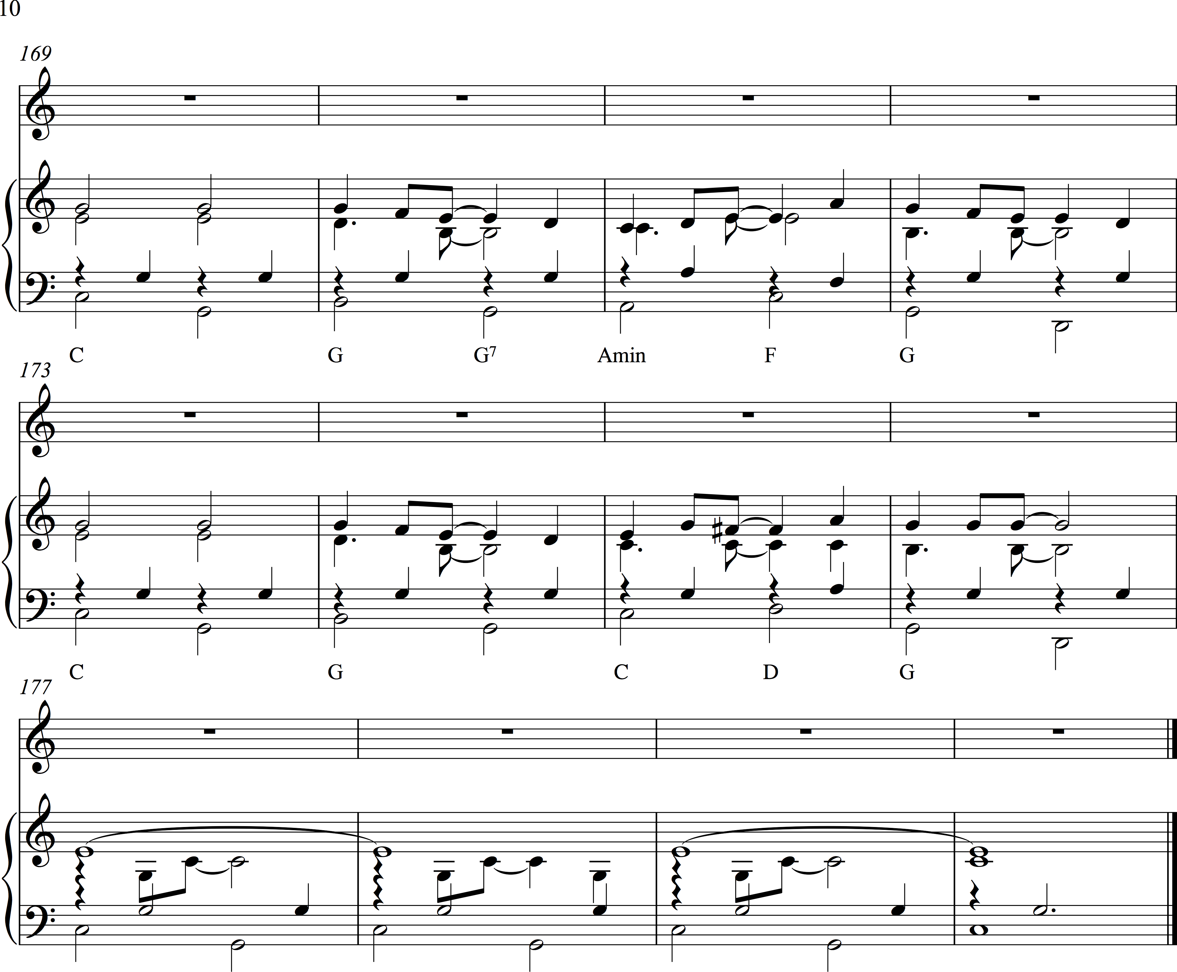

Schools Cantata 2017

ANNUAL SCHOOLS CANTATA 2017

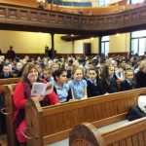
Getting ready for the celebration
Glasgow Churches Together (GCT) held their annual schools cantata in November in Wellington Church of Scotland which has proved to be a popular venue for the celebration. This year the church was encased in scaffolding but its welcome was as warm as ever.
The assistant minister, Rev Roger Sturrock, greeted a sea of schoolchildren and their teachers who filled the church with the colours of their uniforms and school banners and their excitement, as well as providing a snapshot of the multi-ethnic and multicultural mix that is modern Glasgow. He drew their attention to the carving of a dove which graced the pulpit and represented the Holy Spirit and he asked that the Holy Spirit would be with them and in them as they enjoyed their cantata.
This year’s cantata was the story of Joseph and Mary – a short story perhaps when based on the Gospels but a beautiful and challenging one which centred on what God asked of both Joseph and Mary, and their very human yet faith-filled response, asking why God had chosen them but accepting his will. In telling the story, the children had the assistance of students from the Royal Conservatoire of Scotland who provided musical support, both instrumental and vocal.
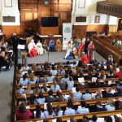
An aerial view of the cantata
The cantata celebration began with a procession of children dressed in character, led by Joseph and Mary. These represented the forebears of Jesus from Abraham to King David, and there were also Scottish guests – Saints Mungo and Columba. Each section of the celebration was introduced by a presenter from a different primary school, all of whom were impressively clear and professional in delivery, and each section of the singing was led by a different primary school.
It was wonderful to experience how the schools, having only come together for the first time that morning for a brief rehearsal, combined to produce a brilliantly smooth and successful performance. Even the sole hitch, when the CD for the dancers from St. Ninian’s Primary refused to play, was resolved with creativity and professionalism, when two of the Conservatoire students offered their services to provide live music – they play in a ceilidh band! – and the young dancers handled the delay and the change in accompaniment so well.
This year is the 350th anniversary of the Royal Faculty of Procurators in Glasgow and the opportunity was taken to remember an earlier legal milestone in Scotland when St Adamnan, Abbot of Iona, persuaded kings and leaders of much of Scotland and Ireland to agree the Law of the Innocents. The children told the story of this event in the form of a newsflash (from 697AD!) and then sang the song in honour of St. Adamnan.
The final part of the celebration consisted of prayers of intercession for issues with which the children could identify: children denied an education; their own families and families who are refugees or living in poverty; for laws to serve the common good and the wellbeing of all people; for peace and for victims of violence and war.
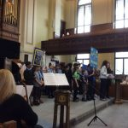
The children line up to give their school’s donations
Every year at the cantata a collection is taken up for a charity chosen by the schools. This year it was for Sr. Pauline Dempsey’s school of St. Patrick in Barbados which has a school roll of 150 children. The children brought their donations down in procession behind their school banners.
Two of the invited guests spoke at the end to express their appreciation of the celebration and the work put in by the children and their teachers . As one put it in a memorable phrase, it had fed her soul, and the message for all takin part was that coming together, they had made something really special for which she thanked them.
The students who had given so much support with their playing now got the opportunity to make their own contribution with a lovely sung piece before Rev. Chris Foxon, Vice Chair of GCT, gave the final blessing. Then, all too soon it seemed, it was time for the final hymn The Hymn of Columba and then the children and their teachers were off to find their buses and back to school.
For the instrumentalists and the adult volunteers and guests, there was a light lunch in Wellington Church’s great Crypt Café where we discovered that there had been an unseen audience – the café staff who had heard the cantata through the gratings in the main church floor and thoroughly enjoyed it.

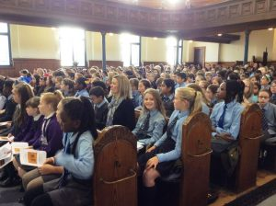
Some more of the children taking part
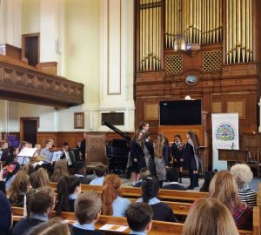

Our dancers with their “ceilidh” band

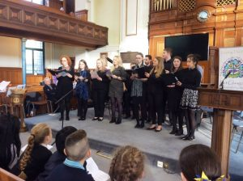

The students get their turn

Joseph and Mary

and The Law of the Innocents

Sponsored by Glasgow Churches Together and the Glasgow Educational and Marshall Trust with the support of music Students from the Scottish Conservatoire, in Wellington Church Tuesday 14th November

Schools arrive from 9.15 – short rehearsals – Cantata at 10.30

Music students sing /play

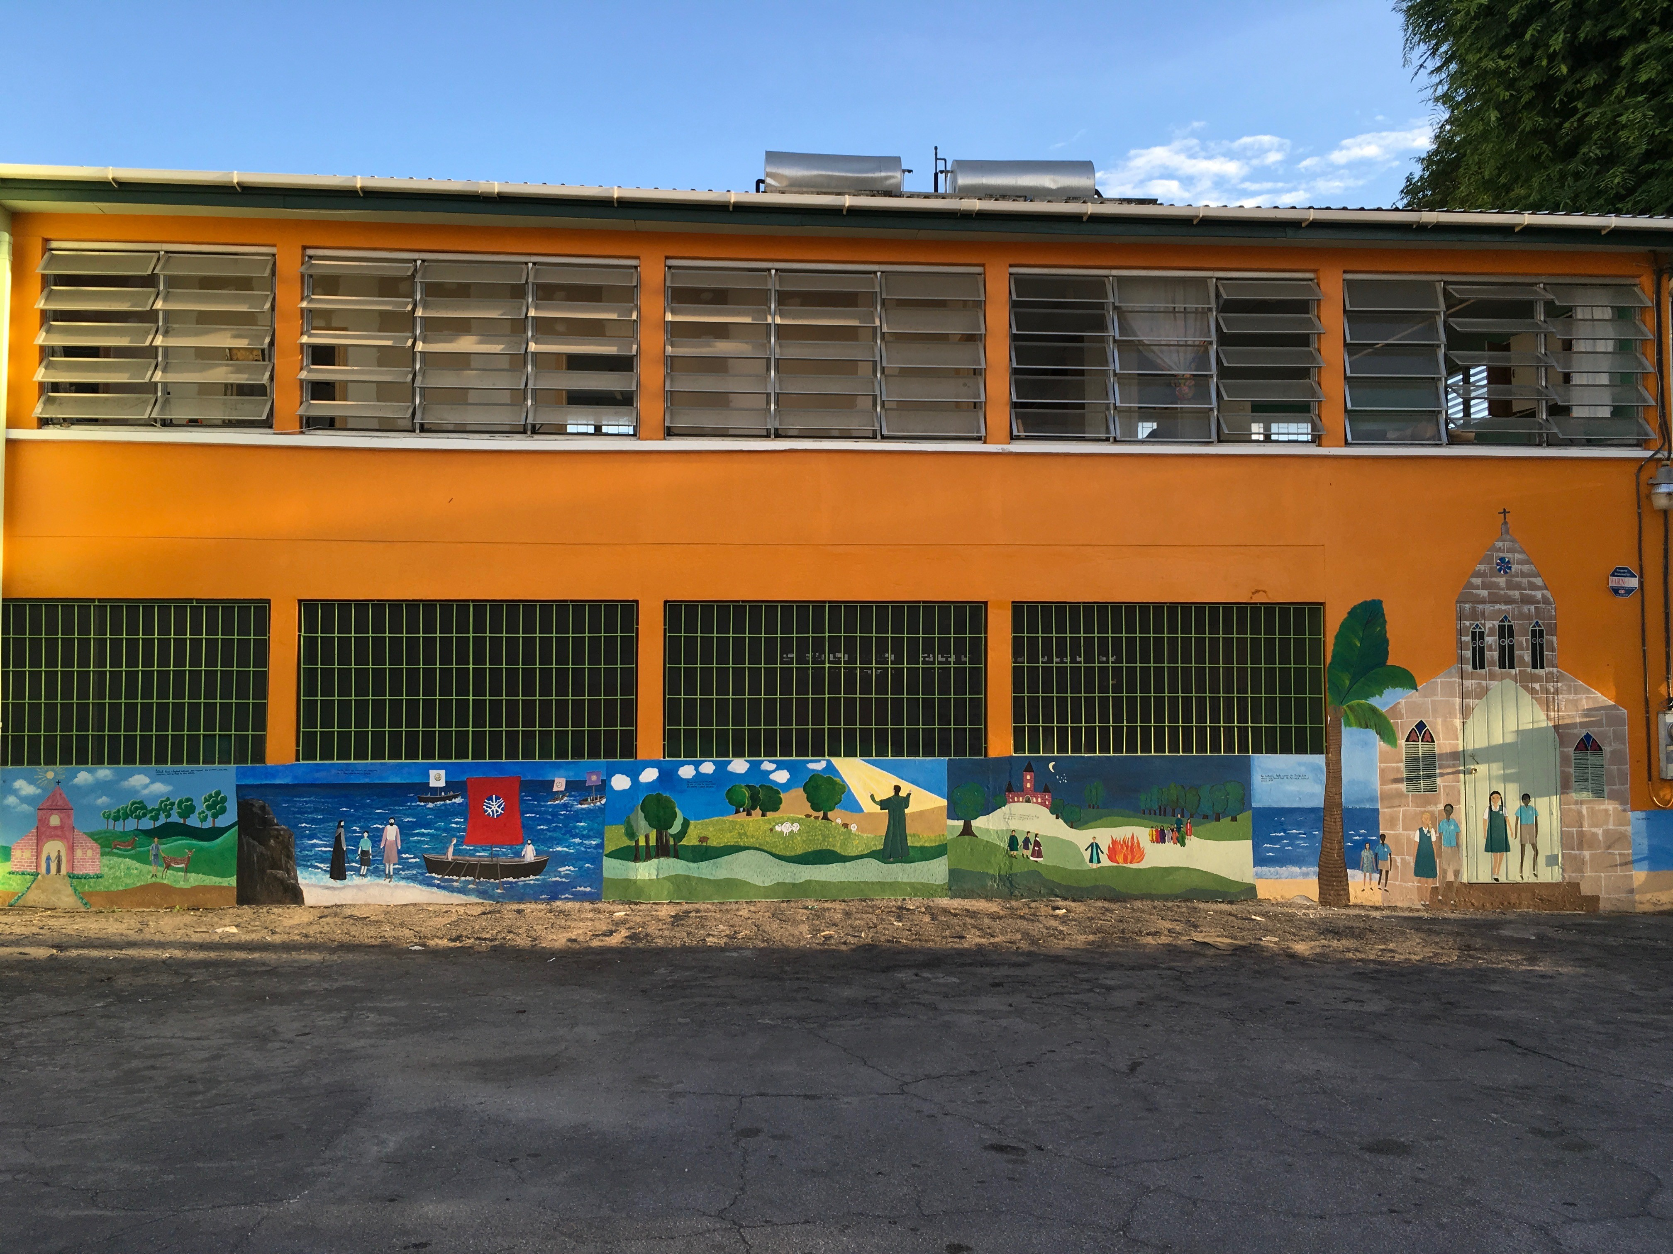

Pauline Dempsey’s School in Barbados.
The Charity we are supporting today.

Students Supporting the Cantata today;

Ewen Brindle, Joanna Ho, Jennifer Lawrie, Craig Scrimgeour – Violins
Lindsey McIntyre - Flute
Blaithin Kerr – Oboe
Lynsay Brown, Gregor Keachie – Trumpet
Dale Parker, Gregor Keachie – Drum-kit
Craig Hart – Accordion
Fiona Dabjen – Saxophone
Stuart Roy – Guitar
Grant Walsh – Bass Guitar
Katy Brown, Kayla McGregor, Jemma McPherson, Heather Mitchell, Sophie Poole – voice.
We Thank You for your Time and Committment

Procession: Joseph and Mary, Abraham, Noah, Ruth, Naomi, Obed, Jesse, King David, with Sts. Mungo and Columba: St Denis’ Primary

God, our Creator: Tune Highland Cathedral
God, our Creator, hear us sing in praise,
God, always tender. God who knows our ways.
God, always present, God who really cares.
We offer thanks for all the love you share.
We sing in praise for the great gifts you give:
all of creation, ev'rything that lives,
glories of nature, our own time on earth,
sending your Son among us proves our worth.

Loud is our praise as we sing of you, one with people of faith, ancient and new. Bless us afresh with your grace, we pray.
Help us witness your love today.

Thanks for the blessings of the talents, skills,
fam’lies and friendships by which lives are filled.
Thanks for the graces, gifts you spread so wide:
those that the world sees and those deep inside.
Even in hard times we can praise your name.
You’re always with us, loving just the same.
Sickness or sorrow, loneliness or doubt,
help us remember your hand reaches out.
Loud is our praise as we sing of you, one with people of faith, ancient and new. Bless us afresh with your grace, we pray.
Help us witness your love today.

God, our Creator, hear us in sing in praise,
God, always tender, God who knows our ways.
God, always present, God who really cares.
We offer thanks for all the love you share.

Book carried by a pupil from Our Lady of the Missions Primary
who says:
‘Father of us all,
this book contains the dreams and hopes of your people.
May it inspire people everywhere
to be guided by your love.”

Welcome : Rev Roger Sturrock, Wellington Church
Welcome: by pupil from Golfhill Primary in Gaelic and by a pupil from Alexandra Parade Primary in English in these or similar words:

“Good Morning everyone we would like to thank you for attending today and welcome you to this beautiful church surrounded by the buildings of Glasgow University, an area which is steeped in history.
We have all been working hard over the last few weeks on the music and readings for the Story of Joseph and Mary. We will also look at the efforts of Adamnan to give people the protection of the law
We hope you enjoy this morning as much as we intend to do.

A pupil from St Denis’ Primary gives an Introduction to the robed characters – Joseph and Mary, Abraham, Noah, Ruth, Naomi, Obed, Jesse, King David, with Sts Mungo and Columba

A Reading by a pupil from St Bartholomew’s Primary
And Joseph also went up from Galilee, from the town of Nazareth, to Judea, to the city of David, which is called Bethlehem, because he was of the house and lineage of David, to be registered with Mary, his betrothed, who was with child. And while they were there, the time came for her to give birth. And she gave birth to her firstborn son and wrapped him in swaddling clothes and laid him in a manger, because there was no place for them in the inn.
And in the same region there were shepherds out in the field, keeping watch over their flock by night. And an angel of the Lord appeared to them, and the glory of the Lord shone around them, and they were filled with great fear. And the angel said to them, “Fear not, for behold, I bring you good news of great joy that will be for all the people. For unto you is born this day in the city of David a Saviour, who is Christ the Lord. And this will be a sign for you: you will find a baby wrapped in swaddling clothes and lying in a manger.”
And suddenly there was with the angel a multitude of the heavenly host praising God and saying,
“Glory to God in the highest,
and on earth peace among those with whom he is pleased!”^{[c]}

Psalm 26: led by Our Lady of the Missions

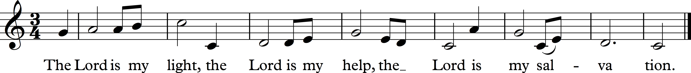

The Lord is my light, the Lord is my help, the Lord is my Salvation.

The Lord is my light, my help, my salvation,
Why should I fear? With God I fear no-one.
God protects me all my life,
with the Lord what should I dread?

The Lord is my light, the Lord is my help, the Lord is my Salvation.

There is one thing I ask of the Lord,
that I long for all my days:
with God to be dwelling, gazing with awe at the beauty of God,
and in wonder look on God’s house.

The Lord is my light, the Lord is my help, the Lord is my Salvation.

I know I will live to see the Lord’s goodness,
now in this life I am sure I will see it.
Trust in the Lord, be strong and be brave;
wait in hope for God, our salvation.

The Lord is my light, the Lord is my help, the Lord is my Salvation.

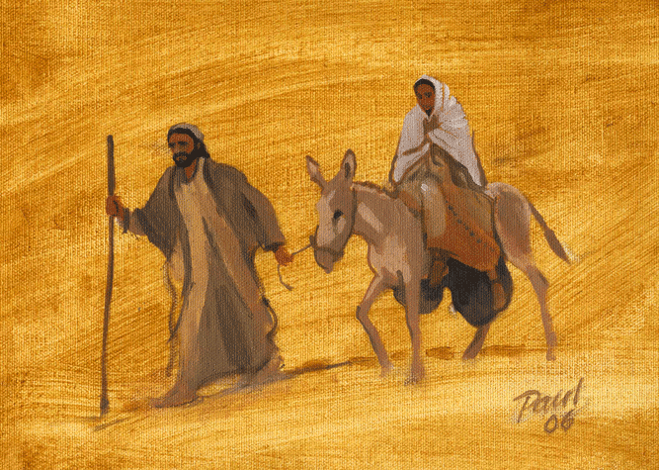

A pupil from Knightswood Primary introduces the Cantata in these or similar words:

“This is the story of Joseph, descendant of King David, a carpenter, a quiet strong man who – as husband of Mary and step-father to Jesus – cared for his family.

The Story of Joseph and Mary

All the children are welcome to join in the story but it will be led by a few pupils from several schools

St Ann’s When Romans ruled the whole known world,
Controlled both land and sea.
When Caesar’s legions first approached
these shores in times B.C.

St Paul’s: In a corner of the Roman dominion,
‘neath the hills of Galilee,
there was born a boy called ‘Joseph,’
nothing special his friends could see.
All: Joseph, son of David, son of Solomon the Wise,
Joseph, carpenter and husband, Guardian of the Child.
Joseph, guardian of the mother and the Child,
Joseph, Joseph, so reliable and strong.

Joseph, son of David, son of Solomon the Wise,
Joseph, carpenter and husband, Guardian of the Child.
Joseph, guardian of the mother and the Child,
Joseph, Joseph, so reliable and strong.

St Ann’s: As a young man Joseph had to
Make his way in life;
When the time came he chose Mary
As the perfect wife.

St Paul’s: Mary, daughter of Anna and Joachim,
Was so young and full of charm.
Joseph asked for their betrothal,
He would love and care for her.

All: Joseph, son of David, son of Solomon the Wise,
Joseph, carpenter and husband, Guardian of the Child.
Joseph, guardian of the mother and the Child,
Joseph, Joseph, so reliable and strong.

St Ann’s and St Paul’s: At her prayers one day young Mary
Heard the angel Gabriel say:
‘Mary, God has loved you dearly,
You will bear a child for him.’
Mary:
St Monica’s and all: Joseph, Joseph, dear Joseph,
What are we to do?
We always knew
That someone would be chosen,
But why, why me and you?
Why, why me and you?

Joseph
Our Lady of the Rosary and all:
Mary, Mary, I love you,
and while I may not understand –
God told our people through Isaiah
A child would be born to his command,
A child would be born to his command.

Joseph
Knightswood Primary and all
Mary, Mary, we are honoured,
no matter what people may say.
Knowing that we are in his service,
Faith and love tell us we must obey.
Faith and love tell us we must obey.

Dancers: from St Ninian’s Primary, Knightswood

A short introduction about Law being for everyone.

This year is the 350th anniversary of the founding of the Faculty of Procurators in Glasgow – to assist people in applying the law to help people. But more than 800 years before that, the 9th Abbot of Iona, Adamnan or in Gaelic ‘Eunan’, persuaded the kings and leaders of much of Scotland and Ireland to agree ‘the Law of the Innocents.’
Let’s see and hear the story and then sing the song:

Newsflash: Adamnan’s Law (St Paul’s, Whiteinch)

1 We interrupt this service to bring you an important newsflash.

2 This is ‘News at 697AD’, and I am N…..

We are receiving some breaking news from Ireland, from the ‘Synod of Birr’, where political and religious leaders from Ireland, Scotland and the lands of the Picts, are discussing some significant new international legislation.

We are going over to our correspondent, N… , for more details. . . . . . . . . .

Adamnan’s song - led by St Ann’s and St Paul’s

Eunan, Adamnan, guide us today. By your example teach us to pray.
Help us to strive for justice and peace, to live out our faith in Jesus,
To live out our faith in Jesus,
1 Eunan, great Celt, both scholar and monk,
Known as Adamnan, abbot and saint,
Throughout these islands, down all the years
Your witness stays strong and pow’rful

Eunan, Adamnan, guide us today. By your example teach us to pray.
Help us to strive for justice and peace, to live out our faith in Jesus,
to live out our faith in Jesus,

2 There, to Iona, your special place,
All folk would come in time of distress.
Refugees, pilgrims, lawyers and kings
Found welcome and peace and wisdom.

Eunan, Adamnan, guide us today. By your example teach us to pray.
Help us to strive for justice and peace, to live out our faith in Jesus,
to live out our faith in Jesus,

3 Fighting the curse of feuding and war,
Women and children suffering more,
You took their side, established the law,
Protecting the rights of the innocents.

Eunan, Adamnan, guide us today. By your example teach us to pray.
Help us to strive for justice and peace, to live out our faith in Jesus,
to live out our faith in Jesus,

4 Loving the scriptures, hist’ry and prayer
helped you discern where customs could change,
helped people reach a greater accord
to build up the church’s unity.

Eunan, Adamnan, guide us today. By your example teach us to pray.
Help us to strive for justice and peace, to live out our faith in Jesus,
to live out our faith in Jesus,

Intercessions

1 St Ninian’s Primary
We thank God for our schools and teachers.
We pray for children everywhere whose right to education is denied.

Sung response led by St Ninian’s Primary:

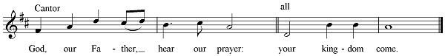

We sing: God, our Father, hear our prayer: your kingdom come

2 Knightswood Primary

We pray for the families of all the children in our schools;
for families who are refugees, and for families who are poor.
We sing: God, our Father, hear our prayer: your kingdom come

3 Golfhill Primary Primary

We pray that the laws of our country will always serve the Common Good and the well-being of all the people.
We sing: God, our Father, hear our prayer: your kingdom come

4 Alexandra Parade Primary

We pray for our city and for our governments, in Edinburgh and Westminster, and for our Head of State, Queen Elizabeth the 2nd.
We sing: God, our Father, hear our prayer: your kingdom come

5 St Monica’s Primary

We pray for peace, for the work of the United Nations, and for all victims of violence and war.

The sung Our Father – led by Our Lady of the Rosary Primary
Our Father in heaven, hallowed be your name,
Your kingdom come,
Your will be done on earth as in heaven.
Give us today our daily bread.
Forgive us our sins
As we forgive those who sin against us.
Save us from the time of trial
And deliver us from evil.
For the kingdom, the power,
And the glory are yours, now and forever, Amen

Now we have our procession with banners and the donation for Pauline Dempsey’s school in Barbados while the Accordianist plays

Thanks by St Monica’s Primary in Spanish, with Signing in Makaton
thanks by St Ninian’s Primary in English;
thanks by Golfhill Primary in Gaelic

A speaker from the education department

A speaker from the chosen charity – Pauline Dempsey’s school in Barbados

The Lord Provost of Glasgow or representative

Rev Roger Sturrock
Students sing/play

The blessing is led by Rev Chris Farren, Vice-chair of Glasgow Churches Together

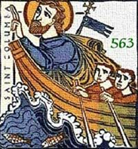

A Hymn of Columba – The Iona Boat Song

The love of our Lord will temper our shame,
The grace of the Gospel direct.
Our faith is the shield to cover our pride
And our spiritual sword will protect.
All glory to God, the Father of all, to the Son and the Spirit give praise.

Now safe on this land we worship our God,
our glorious father, our king
From Ireland to Scotland our torch and our trust
through the treacherous waters did bring.
All glory to God, the Father of all, to the Son and the Spirit give praise.

Oh, circle us now with love and with peace.
Our strength and our guide, Lord, we pray.
We have nothing to fear when you are so near.
You are King of the night and the day.
All glory to God the Father of all, to the Son and the Spirit give praise.

I ask you, my God, to bless and protect
The fam’ly and friends that I love.
Enfold us in love, surround us with peace;
Be our strength and our light and our life.
All glory to God the Father of all, to the Son and the Spirit give praise.

Glasgow Churches Together thanks the pupils and staff from the schools involved, and the music students and staff from the Scottish Conservatoire, responsible for today’s celebration. A particular thanks to the community and staff at Wellington Church, the Lord Provost’s office, the Glasgow Educational and Marshall Trust and everyone who contributed in any way to today’s celebration.

The Band plays
Schools go back for lunch
Guests, Students and Staff descend to the crypt café for a light Lunch



Copyrights: God, our Creator: words © Stephen Eric Smyth, Ps 26 © Christopher Walker. Cantata © Loreno Rinaldi and Gerry Fitzpatrick. Response to the Intercessions: music © John Bell. Words of the ecumenical version of the Lord’s Prayer © ICEL. The Iona Boat Song: words © Bill McLaughlin and Pam Murray.

Adamnan’s Law
Or The Law of the Innocents
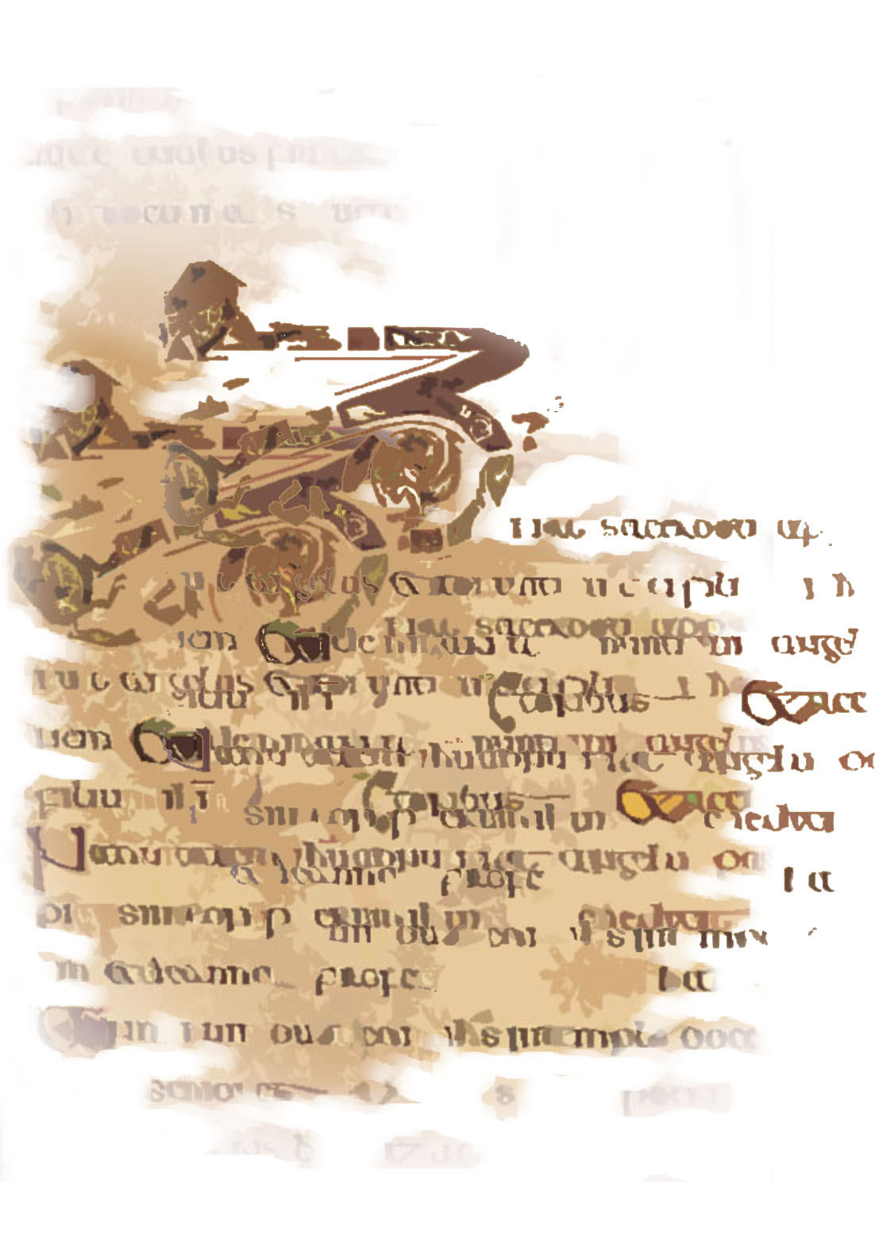

Adamnan, or Eunan, was the 9th Abbot of Iona and was influential at the Synod of Byrr in persuading the Dalriadan (parts of the West of Scotland and the North east of Ireland) rulers to accept that in time of war the innocents should be protected.A song written for and first sung by children of St Eunan’s Primary, Clydebank 2004 © Stephen Eric Smyth and Gerry Fitzpatrick.

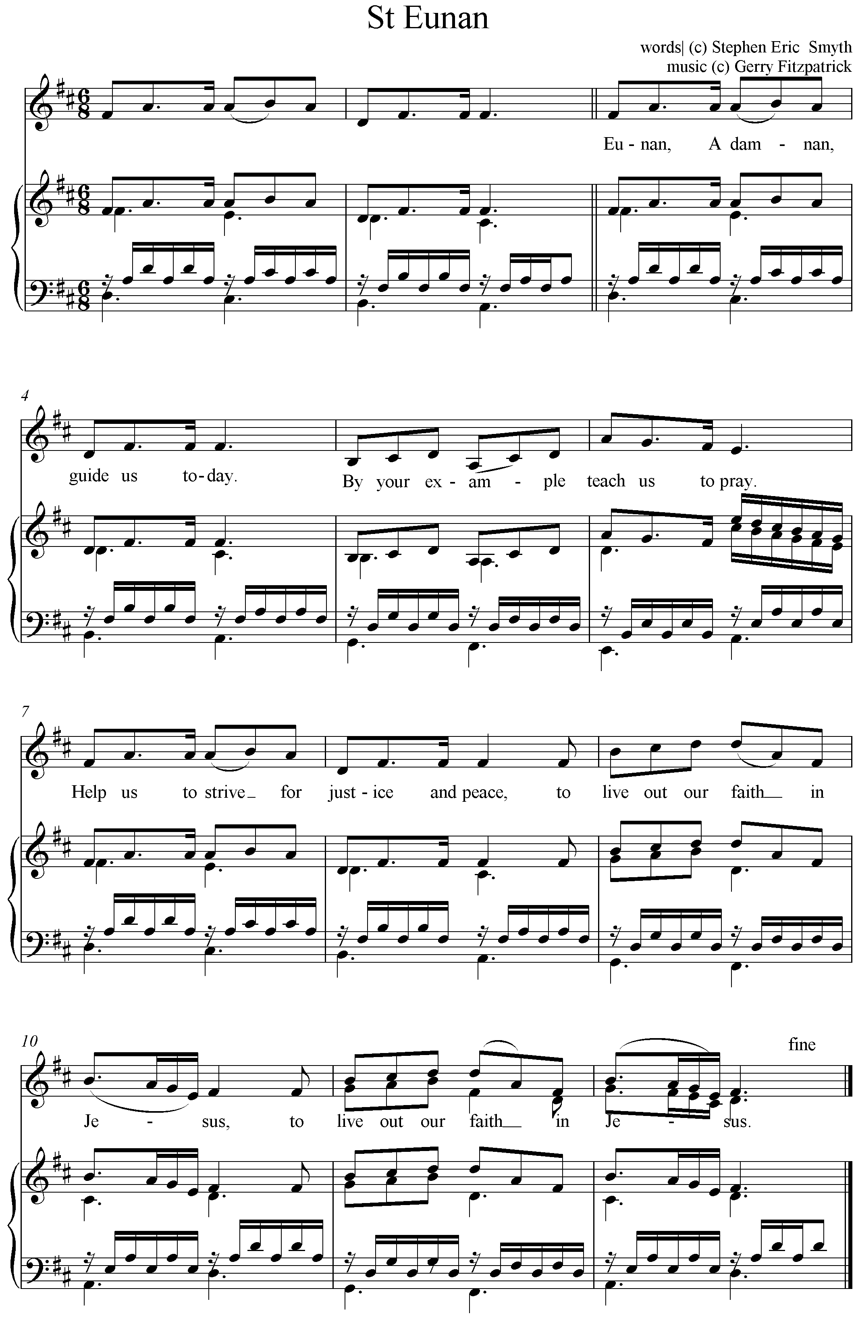
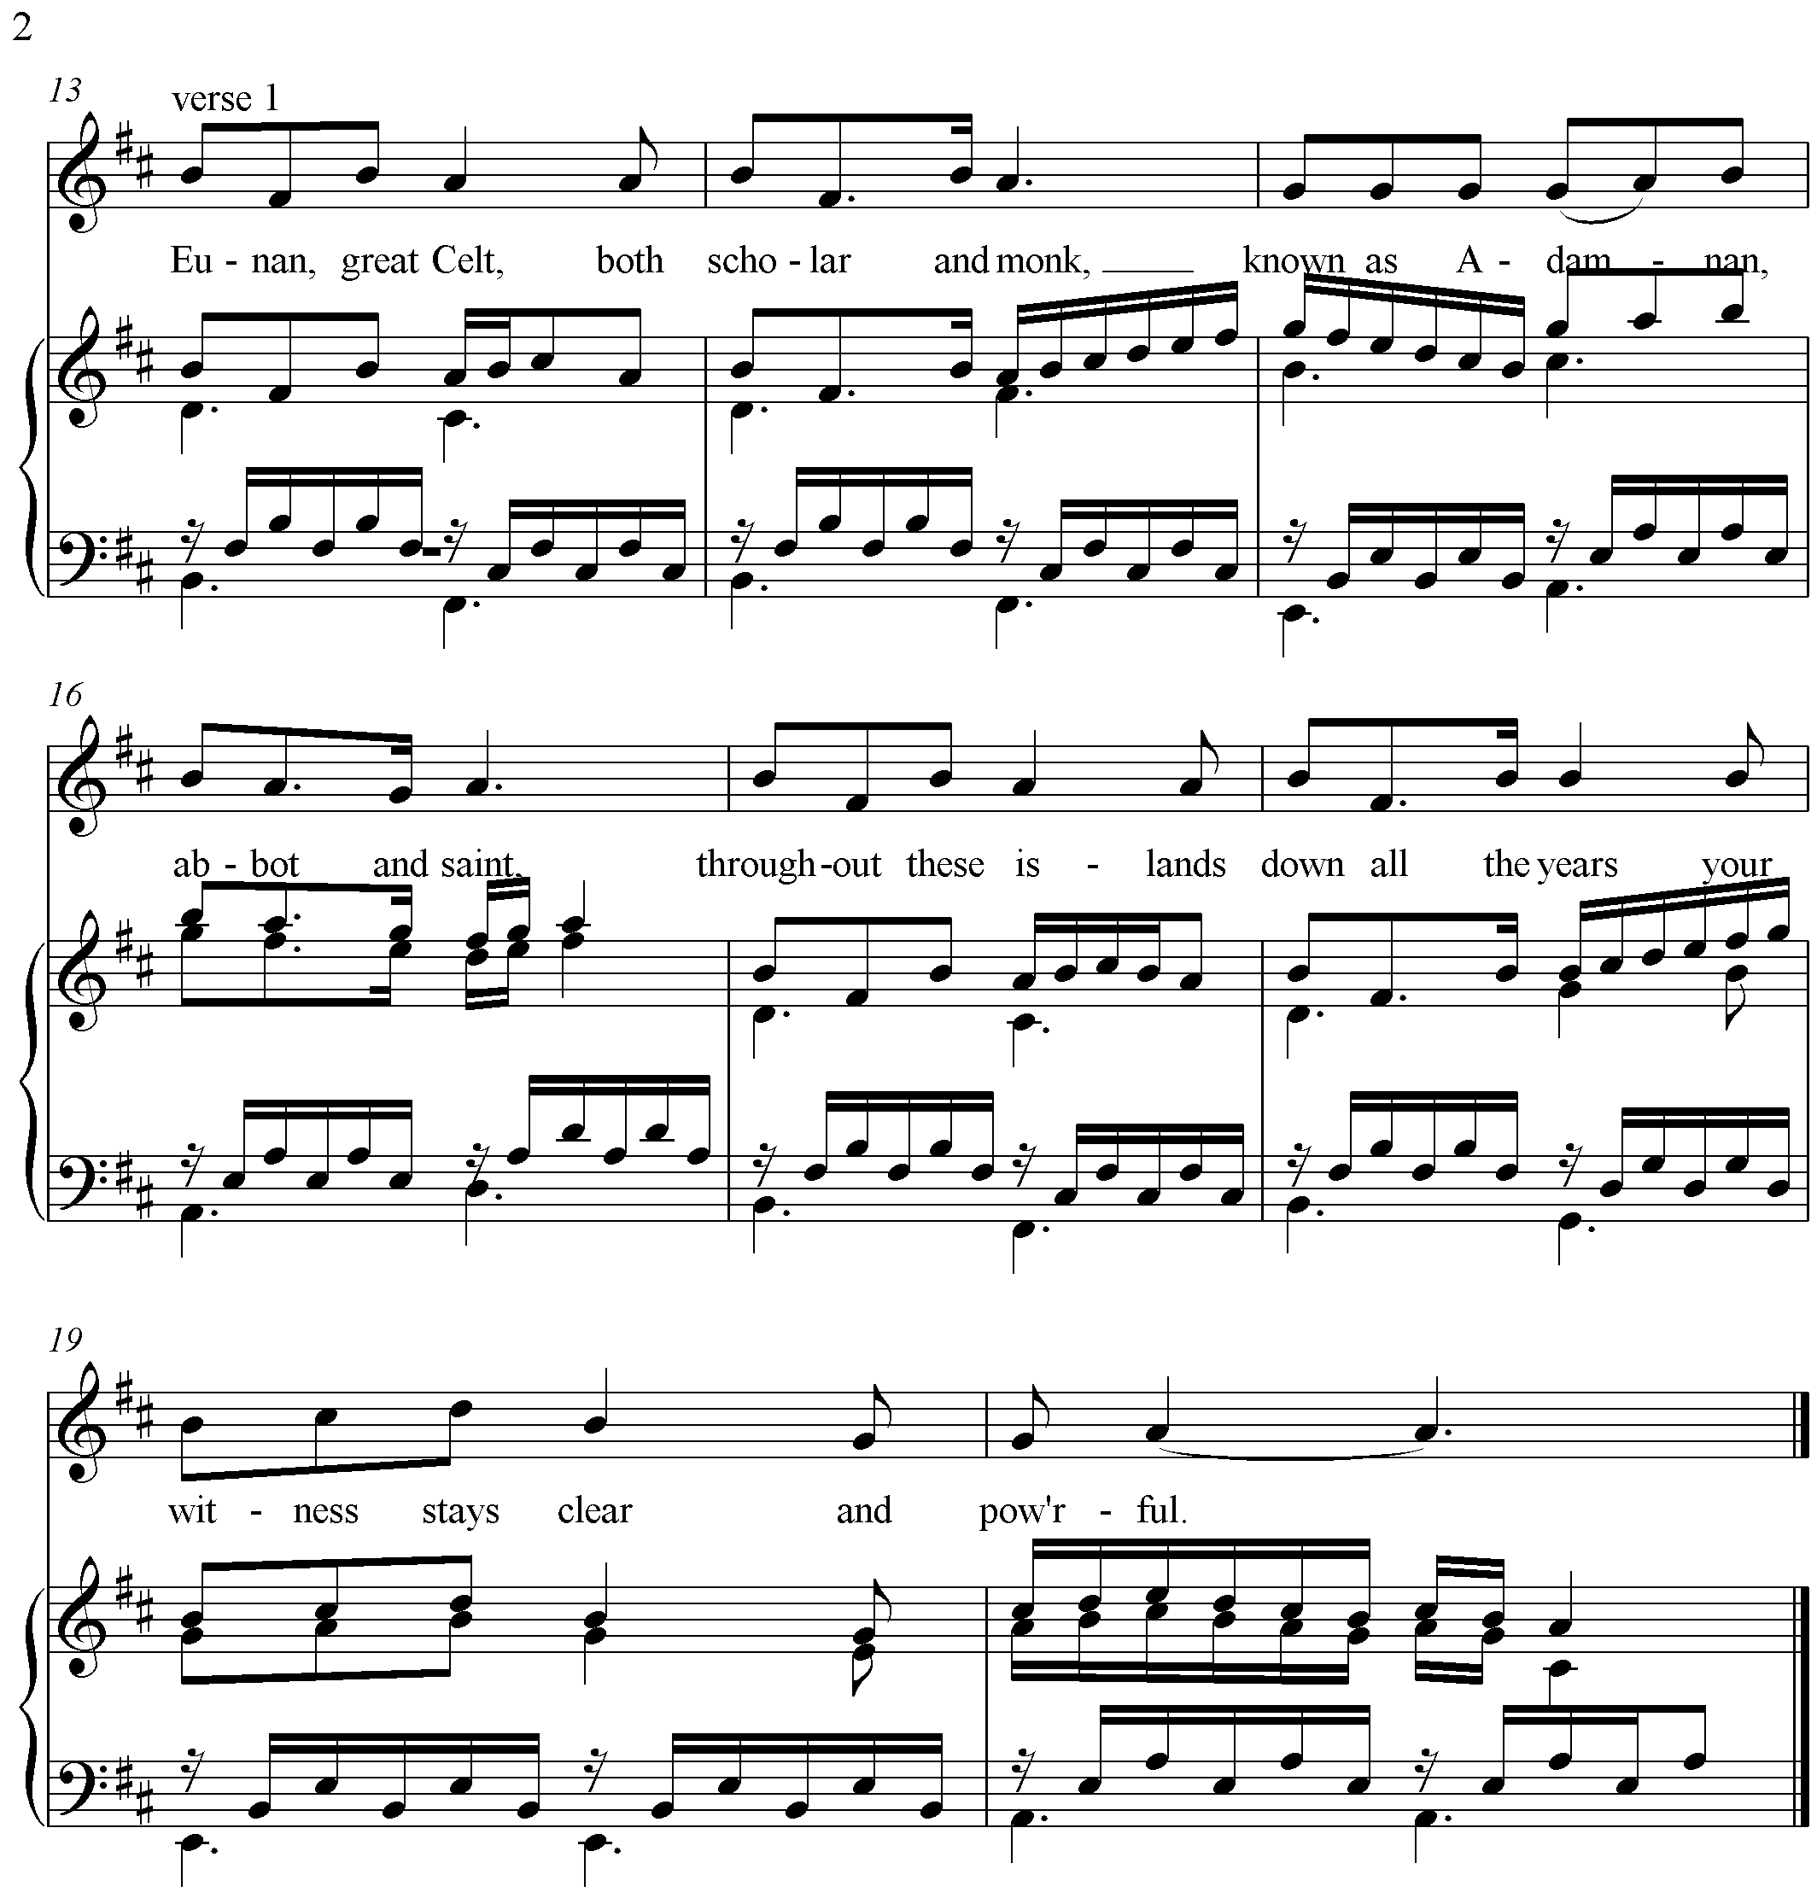

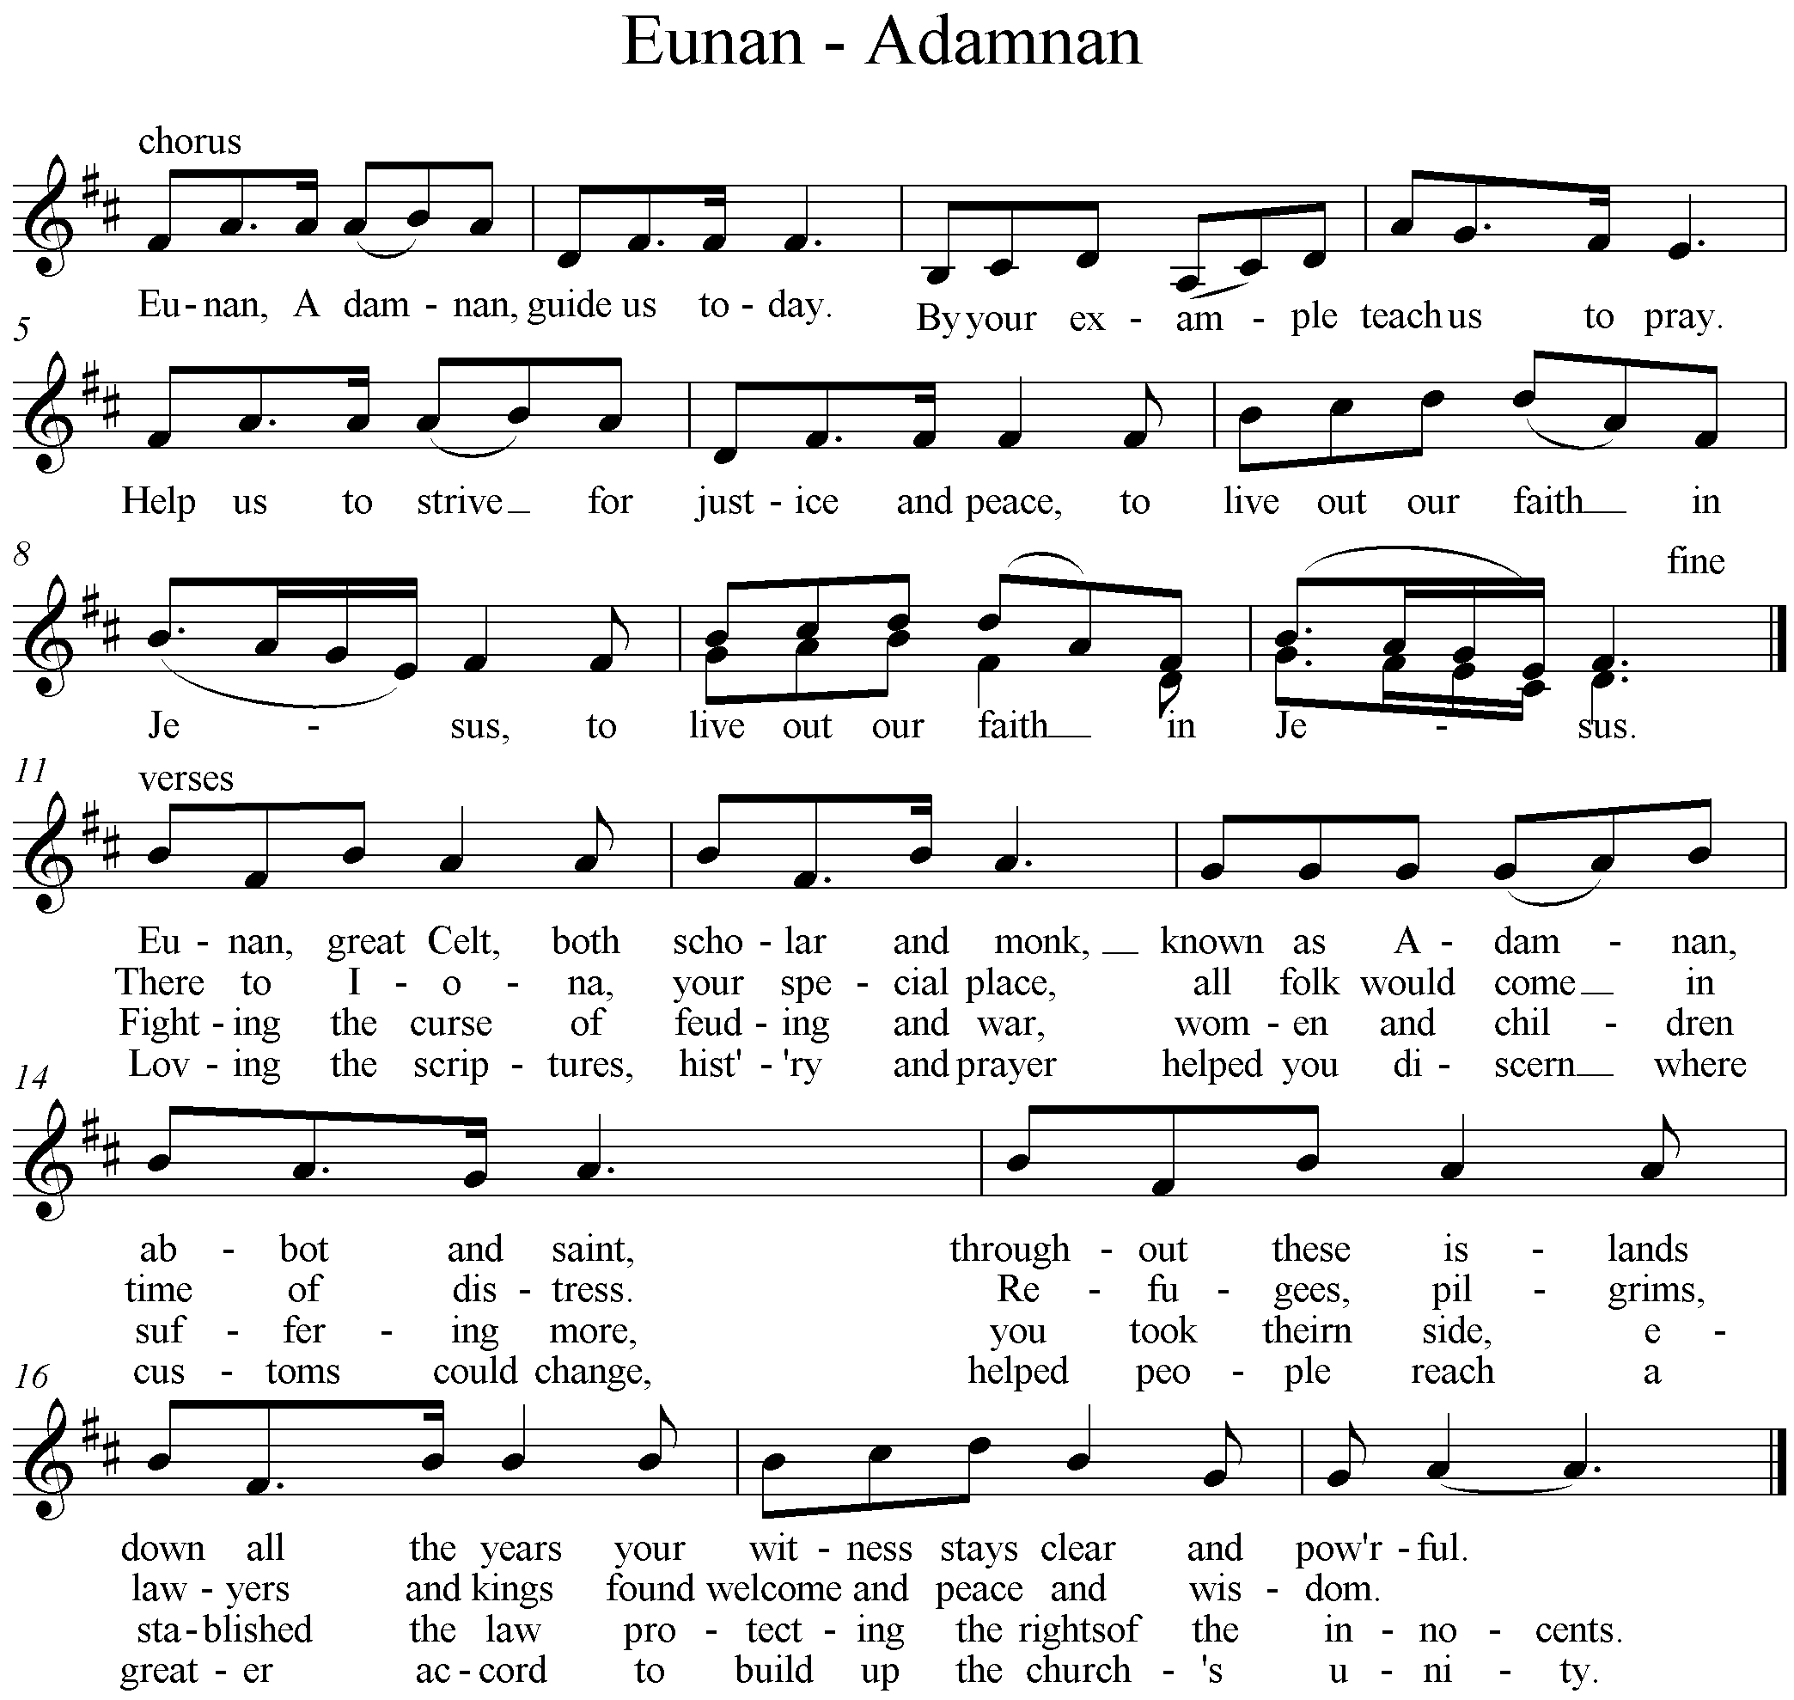

Graphic © Netta Ewing
St Mungo Music, St Leo’s, 5 Beech Avenue, Glasgow G41 5BY

Morning Prayer

St Joseph’s Day

You alone are holy and you alone are Lord,
And you alone are the Most High, Jesus Christ our Lord.

O God, come to our aid: O Lord, make haste to help us.
Glory to the Father, glory to the Son,
glory to the Holy Spirit now and for ever. Amen.

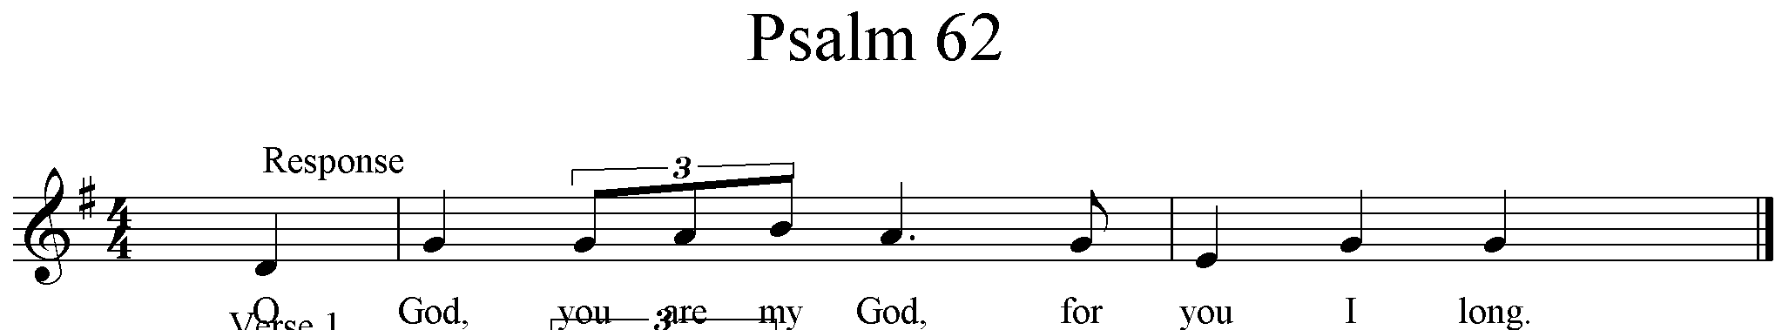

O God, you are my God, for you I long, for you my soul is thirsting.
My body pines for you, my God, like a dry weary land without water. O God,

I gaze on you in the sanctuary to see your strength and glory,
for your love is better than life itself; my lips will speak your praise. O God,

On you I muse throughout the night, on my bed I remember you,
for you have been my refuge and your right hand holds me fast. O God ..

Glory to the Father, glory to the Son,
glory to the Holy Spirit now and for ever. Amen. O God, you . . . .

Let us pray

Almighty God,
at the beginnings of our salvation,
When Mary conceived your Son and brought him forth into the world,
You placed them under Joseph’s watchful care.
May his prayer still help your Church
to be an equally faithful guardian of your mysteries
and a sign of Christ to mankind.
We make our prayer through Christ our Lord. Amen.

Gloria

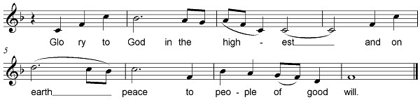
We praise you, we bless you, we adore you, we glorify you,
we give you thanks for your great glory,
Lord God, heavenly King, O God, almighty Father.
Lord Jesus Christ, Only Begotten Son,
Lord God, Lamb of God, Son of the Father,
you take away the sins of the world, have mercy on us;
you take away the sins of the world, receive our prayer;
you are seated at the right hand of the Father, have mercy on us.
For you alone are the Holy One, you alone are the Lord,
you alone are the Most High, Jesus Christ,
with the Holy Spirit, in the glory of God the Father. Amen.

Gospel Acclamation
Praise to you, O Christ, king of eternal glory. Praise to you, O Christ, king of eternal glory. This is what the Lord asks of you, this, only this: to act justly, love tenderly and walk humbly with your God. Praise to you . . .

Intercessions
St Joseph is Patron of the universal Church, so let us pray
for the Pope and all the Bishops of the Church
that they may be guided in their ministry.
Lord in your mercy R. Hear our prayer

We pray for families, that parents may have wisdom in the
upbringing of their children, and that children may be loving
and appreciative of their parents. Lord in your mercy

We pray for artists and craftsmen that they may, in following
the example of St Joseph, be just and patient, faithful and true.
Lord in your mercy R. Hear our prayer

St Joseph is patron of the dying. We pray for grace of a happy
death and we remember those who are dying today. Lord in your . . .

We sing:
How precious is your love, O Lord, your everlasting love.
How precious is your love, O Lord, your unfailing love.,

Sanctus Memorial Doxology Amen Agnus Dei

Communion: I come that you may have life, life to the full, says the Lord. I come that you may have life, life to the full, says the Lord.
Blessing for Brother Julian on his pilgrimage to Compostella

May the God who called our father, Abraham,
To journey into the unknown,
And guarded him and blessed him,
Protect you too and bless your journey.
May his confidence support you as you set out,
May his Spirit support you on the way,
And may he lead you back to your home in peace.
Those you love we commend to his care.
He is with them, you need not fear.
As for yourself,
May his presence be your companion,
So that blessing may come to you
And to everyone you meet.
Blessed are you, Lord,
Whose presence travels with his people.
May almighty God, bless you,
the Father, the Son and the Holy Spirit. Amen

Final
Such are the ones who seek your face, who seek your face, O Lord.
Such are the ones who seek your face, who seek your face, O Lord.
Glory to the Father, glory to the Son,
Glory to the Holy Spirit now and for ever. Amen.
Such are the ones who seek your face, who seek your face, O Lord.

Copyrights: O God, come: © Gerry Fitzpatrick. Psalm 62 : Words taken from The Psalms : A New Translation published by William Collins & Co Ltd © The Grail. Intercessions: Robert McDonald. Blessing based on a Jewish Prayer.

